Hazardous Air Pollutants

Introduction
This section includes pollutants singled out for control under recent international protocols of the UN/ECE under the Convention on Long-range Transboundary Air Pollution- namely Persistent Organic Pollutants (POPs) and Heavy Metals (HMs).

UN/ECE Heavy Metals and POPs Protocols
The Convention on Long-range Transboundary Air Pollution was signed in 1979 and entered into force in 1983. Since its entry into force the Convention has been extended by a number of protocols, including the 1998 Protocol on Heavy Metals and the 1998 Protocol on POPs. These two Protocols are given in outline below; more information may be found at the UN/ECE web site, located at:- http://www.unece.org/env/lrtap/. The UK has signed both of these protocols.

Persistent Organic Pollutants (POPs)
The UN/ECE Protocol on Persistent Organic Pollutants focuses on a list of 16 substances (or groups of substances), that have been identified according to certain risk criteria. In brief, these 16 pollutants may be classified in three source sectors as follows:

- Pesticides: aldrin, chlordane, chlordecone, DDT, dieldrin, endrin, heptachlor, hexachlorobenzene (HCB), mirex, toxaphene, hexachlorocyclohexane (HCH, which includes “lindane”);

- Industrial Chemicals: hexabromobiphenyl, polychlorinated biphenyls (PCBs);

- By-products or Contaminants: dioxins, furans, polycyclic aromatic hydrocarbons (PAHs).

The ultimate objective of the protocol is to eliminate any losses, discharges and emissions of POPs to the environment. This is achieved through several different legislative mechanisms. First, the production and use of several compounds is banned (aldrin, chlordane, chlordecone, dieldrin, endrin, hexabromobiphenyl, mirex and toxaphene). Second, several compounds are scheduled for elimination at a later date (DDT, heptachlor, hexachlorobenzene, PCBs). Finally, the protocol severely restricts the use of selected compounds (DDT, HCH- including lindane and PCBs). Limited uses which are thought to be essential and for which there are no adequate substitutes can be exempted. For instance, the use of substances like DDT would be allowed under the protocol for public health emergencies. The protocol includes provisions for dealing with the surplus of products that will be banned.

Under the protocol, countries are also required to reduce their emissions of dioxins, furans, PAHs and HCB below their levels in 1990 (or an alternative year between 1985 and 1995). The protocol requires the best available techniques (BAT) to be applied to cut emissions of these POPs. For the incineration of municipal, hazardous and medical waste, it lays down specific limit values. The protocol allows for the addition of further compounds into control, depending on the development of the scientific basis for such an action.

In 1999, EPAQS (Expert Panel on Air Quality Standards) published a report on PAHs which recommended an Air Quality Standard of 0.25 ng m⁻³ benzo[a]pyrene as an annual average. As a result, further work assessing the concentrations of PAHs in the atmosphere has been commissioned by Defra and the results compared with the spatially disaggregated emissions inventory.

In August 2002, PAHs were added to the list of pollutants covered by the Air Quality Strategy for England, Scotland, Wales and Northern Ireland (see Section 6.2), and an objective was set relating to the PAH concentrations in the air. As a consequence there is a continued drive to decrease PAH emissions from the major sources.

Continued improvements have been made in compiling the 2003 UK emission estimates for POPs. This has been instigated in a response to the increasing interest in hazardous air pollutants and their impact on the environment over the last several years. The level of data available for many of these pollutants is relatively limited and hence several areas of the current emission inventory have been targeted for improvements which will be included in future emission estimates as a part of the NAEI continuous improvement process.

Table 6.1 lists the toxic pollutants (i.e. POPs and heavy metals) included in the current inventory together with their total UK emissions in 2003. Each of the pollutant classes are considered in more detail in the following sections.

Heavy Metals
The UN/ECE Protocol on Heavy Metals targets three particularly harmful substances: lead, cadmium and mercury. Countries are obliged to reduce their emissions of these three metals below their levels in 1990 (or an alternative year between 1985 and 1995). The protocol aims to cut emissions from industrial sources (iron and steel industry, non-ferrous metal industry), combustion processes (power generation, road transport) and waste incineration.

The protocol specifies limit values for emissions from stationary sources and requires BAT for obtaining emission reductions from these sources, such as special filters or scrubbers for combustion sources or mercury-free processes. The protocol also requires countries to phase out leaded petrol.

Under the protocol, measures are introduced to lower heavy metal emissions from other products e.g. mercury in batteries, and examples are given of management measures for other mercury-containing products, such as electrical components (thermostats, switches), measuring devices (thermometers, manometers, barometers), fluorescent lamps, dental amalgam, pesticides and paint.

Further metals may be added to the protocol, and further measures may be introduced for lead, cadmium and mercury, depending on the development of the scientific basis for action.

The best known effects of heavy metals are those on humans and animals. Of these, the most important effects are deterioration of the immune system, the metabolic system and the nervous system. They lead to disturbances in behaviour and some heavy metals are suspected to be or have been proven to be carcinogenic.

The impact of heavy metals on the environment due to long-range transport can be summarized as:

- Impact on aquatic ecosystems. Atmospheric deposition of metals may influence the quality of surface waters and ground water. In addition to the effects on the uses of water (e.g. restricted use of water for human consumption, livestock, recreation etc) accumulation in aquatic organisms may have adverse effects on the food web.
- Impact on terrestrial systems. Metal uptake by plants is a key route for the entry of metals into the food chain. Contaminants may be toxic to plants and can alter the structure or diversity of a habitat. When plants accumulate metals, these can be ingested by animals creating the potential for toxic effects at higher trophic levels.
- Mesofauna and macrofauna. The accumulation of cadmium and lead in birds and mammals in remote areas is attributable to long range atmospheric transport.
- Agricultural products. Airborne heavy metals account for significant fractions of the total heavy metal input to arable soils.

Major environmental problems due to long range transport have been reported, relating to the:
- Accumulation of Pb, Cd and Hg in forest top soils, implying disturbed nutrient recirculation in forest ecosystems and increased stress on tree vitality in central Europe, reinforced by the acidification of soils
- Highly increased content of Hg in fish from lakes, especially in Scandinavia.

Table 6.1 Total UK Emissions of Toxic Pollutants
Pollutant | Total 2003 UK emission
Persistent organic compounds (POPs)  - Polycyclic aromatic hydrocarbons (PAHs) | 1563 | tonnes (USEPA16)¹
- Dioxins and Furans (PCDD/F) | 259 | I-TEQ grammes²
- Polychlorinated biphenyls (PCBs) | 1.38 | tonnes
- Pesticides |  | tonnes
- lindane (γ-HCH)  - pentachlorophenol (PCP)  - hexachlorobenzene (HCB) | 15  437  0.30
- Short Chain Chlorinated Paraffins (SCCPs) | 0.2 | tonnes
- Polychlorinated Napthalenes (PCNs) | NE³
- Polybrominated Diphenyl Ethers (PBDEs) | 7.3
Heavy metals |  | tonnes
- Arsenic | 16.1
- Beryllium | 181
- Cadmium | 5.5
- Chromium | 43.5
- Copper | 65.2
- Lead | 133
- Manganese | 38
- Mercury | 7.4
- Nickel | 179.7
- Selenium | 42.2
- Tin | 5.8
- Vanadium | 1285
- Zinc | 492
¹ See Table 6.3 for different PAHs included under different groupings.
² TEQ- “Toxic Equivalents” is a way of weighting emissions according to their toxicity. See Table 6.4
³ NE - Not Estimated. It has not been possible to make an emission estimate

Persistent organic pollutants
Persistent organic pollutants (POPs) are organic compounds of anthropogenic origin that do not readily break down in the environment. Their long lifetime means that they can be transported over long distances, resulting in widespread distribution across the earth, including remote regions. They accumulate in the food chain, and their toxicity poses a threat to humans and the environment.

Over recent years there has been a growing interest in these pollutants and in particular their potential chronic toxicity and impacts on human health. This is reflected by the recent international agreement to reduce releases of these chemicals under the UN/ECE Persistent Organic Pollutants Protocol (detailed in Section 6.1) and their consideration for air quality standards by the Expert Panel on Air Quality Standards (EPAQS). The detailed methodology for the compilation of these inventories depends on the combination of emission factors gathered from a range of sources and production statistics used elsewhere in the emission inventory or developed for the specific sector concerned.

The UK NAEI does not include emission estimates for a number of POPs that have been banned in the UK for several years. Table 6.2 below indicates the years in which the use of particular POPs were banned or their use severely restricted, and whether the listed POPs are included in the NAEI.

Table 6.2 POPs Included/Not Included in the NAEI and Corresponding Year of Ban on Use
Compound or Compound Group | Banned in UK | Included in NAEI
Polycyclic aromatic hydrocarbons (PAHs) | - | Yes
Dioxins and Furans (PCDD/Fs) | - | Yes
Polychlorinated biphenyls (PCBs) | - | Yes
Hexabromobiphenyl | Never Used | No
Pesticides
γ-Hexachlorocyclohexane | - | Yes
Pentachlorophenol¹ | 1995² | Yes
Hexachlorobenzene¹ | 1975 | Yes
Aldrin | 1989 | No
Chlordane | 1992 | No
Dichlorodiphenyl-trichloroethane (DDT) | 1984 | No
Chlordecone | 1977 | No
Dieldrin | 1989 | No
Endrin | 1984 | No
Heptachlor | 1981 | No
Mirex | Never Used | No
Toxaphene | Never Used | No
¹ Hexachlorobenzene and pentachlorophenol are also emitted from other sources as well as being or having been active ingredients in pesticides.
² Use of pentachlorophenol is severely restricted rather than banned absolutely.

Polycyclic aromatic hydrocarbons (PAHs)
Polycyclic aromatic hydrocarbons are a large group of chemical compounds with a similar structure comprising two or more joined aromatic carbon rings. Different PAHs vary both in their chemical characteristics and in their environmental sources and they are found in the environment both as gases and associated with particulate material. They may be altered after absorption into the body into substances that are able to damage the genetic material in cells and initiate the development of cancer, although individual PAHs differ in their capacity to damage cells in this way.

The speciated PAH inventory was first compiled for the 1996 emissions inventory (Wenborn et al, 1999) and has allowed a more detailed understanding of the PAH emissions in the UK.

There have been several pollutant classifications relating to PAHs. Although there are a vast number of PAHs, the NAEI inventory focuses on sixteen. These 16 PAHs have been designated by the United States Environmental Protection Agency (USEPA) as compounds of interest using a suggested procedure for reporting test measurement results (USEPA, 1988). A subset of this includes six of the PAHs identified by the International Agency for Research on Cancer (IARC) as probable or possible human carcinogens (IARC 1987). In addition, the Borneff 6 PAHs (another subset focussing on the health impacts of the PAHs) have been used in some EC emission inventory compilations. A further subset of PAHs are those to be used as indicators for the purposes of emissions inventories under the UN/ECE’s Persistent Organic Pollutants Protocol. These classifications are given in the following table.

Table 6.3 The USEPA 16 PAH Primary Pollutants, and other PAH Subsets.
 | Included in the NAEI | USEPA Priority pollutants  (16 PAH) | IARC Probable or possible Human carcinogens  (6 PAH) | Borneff  (6 PAH) | UN/ECE  POPs Protocol  Indicators for purpose of emission inventories
Naphthalene | ✓ | ✓
Acenapthene | ✓ | ✓
Acenapthylene | ✓ | ✓
Fluorene | ✓ | ✓
Anthracene | ✓ | ✓
Phenanthrene | ✓ | ✓
Fluoranthene | ✓ | ✓ |  | ✓
Pyrene | ✓ | ✓
Benz[a]anthracene | ✓ | ✓ | ✓
Chrysene | ✓ | ✓
Benzo[b]fluoranthene | ✓ | ✓ | ✓ | ✓ | ✓
Benzo[k]fluoranthene | ✓ | ✓ | ✓ | ✓ | ✓
Benzo[a]pyrene | ✓ | ✓ | ✓ | ✓ | ✓
Dibenz[ah]anthracene | ✓ | ✓ | ✓
Indeno[1,2,3-cd]pyrene | ✓ | ✓ | ✓ | ✓ | ✓
Benzo[ghi]perylene | ✓ | ✓ |  | ✓

The main environmental impact of PAHs relate to their health effects, focusing on their carcinogenic properties. The most potent carcinogens have been shown to be benzo[a]anthracene, benzo[a]pyrene and dibenz[ah]anthracene (APARG 1996). The semi-volatile property of PAHs makes them highly mobile throughout the environment via deposition and re-volatilisation between air, soil and water bodies. It is possible that a proportion of PAHs released in the UK are deposited in the oceans and/or subject to long-range transport making them a widespread environmental problem.

In 1999 the Expert Panel on Air Quality Standards (EPAQS) published a recommendation for an air quality standard for PAHs. This standard was based on the use of benzo[a]pyrene as an indicator of the overall carcinogenicity of the PAHs present in the atmosphere. In August 2002 PAHs were included in the Air Quality Strategy for England, Scotland, Wales and Northern Ireland (see Section 4.1) through the introduction of an objective relating to concentrations in ambient air.

Emissions of the total amount of the 16 PAHs and benzo[a]pyrene (BaP) are summarised in Tables 6.4a and 6.4b. Whilst BaP emissions are included in the 16 PAHs, it is also considered here individually due to its importance.

Aluminium production and anode baking (carried out for the aluminium industry) was the largest source of PAH emissions in the UK until 1996 (contributing nearly half of the total PAH emission). Emissions since then have declined and in 2003 these sources accounted for only 6% of the emissions. This is a consequence of the closure of the plant at Kinlochleven and investment in abatement equipment following from the authorisation regime implementing the Environmental Protection Act 1990. One of the anode baking plants has dramatically reduced its emissions and the other is timetabled to follow shortly.

Road transport combustion is currently the largest source of PAH emissions contributing 60% of the emissions in 2003. There have been a number of significant revisions to these emission estimates across the last several years. This is due to the limited availability of data on emission factors- and hence very high uncertainty results. The next largest sources of emissions in 2003 were domestic combustion and other forms of industrial combustion.

Emissions of PAH and BaP from domestic combustion increased between 1997 and 1999 but have since declined. This trend follows the reported consumption of coal in the domestic sector (DTI, 2004).

There are several source sectors relevant to PAHs which have been recently improved. Wood treatment is a source of some of the lighter PAHs such as acenapthene, fluorene and anthracene, and emission estimates from this source have been included. Emissions from bitumen production and use have not been estimated due to a lack of emission data. Bitumen use has also recently been included in the emission estimates. It is a significant source of benzo[a]pyrene and several other PAHs.

The most notable recent changes to the BaP inventory include significantly reduced emissions from some industrial sources and smaller road transport emissions. Further details can be found in Coleman et al (2001). Increased measurement of PAHs by both industry and regulators, particularly in the aluminium sector, has allowed improvements in the precision of the emission estimates. The uncertainties associated with the emissions estimates of PAHs are very high, and are considered in Section 6.4.

Table 6.4a UK Emissions of 16 PAHs¹ by UN/ECE Source Category (tonnes)
 | 1990 | 1995 | 1996 | 1997 | 1998 | 1999 | 2000 | 2001 | 2002 | 2003 | 2003%
BY UN/ECE CATEGORY
Combustion in Energy Prod
Public Power | 6 | 4 | 4 | 3 | 4 | 3 | 4 | 4 | 4 | 4 | 0%
Petroleum Refining Plants | 4 | 4 | 4 | 5 | 5 | 5 | 5 | 4 | 4 | 4 | 0%
Other Combustion & Trans. | 10 | 1 | 1 | 1 | 1 | 1 | 1 | 1 | 1 | 1 | 0%
Combustion in Comm/Res
Residential Plant | 766 | 464 | 485 | 471 | 489 | 523 | 411 | 455 | 409 | 305 | 19%
Comm/Agricul Combustion | 30 | 15 | 16 | 17 | 9 | 4 | 2 | 2 | 1 | 1 | 0%
Combustion in Industry
Iron & Steel Combustion | 25 | 22 | 23 | 23 | 24 | 24 | 21 | 19 | 16 | 20 | 1%
Other Ind. Combustion | 366 | 336 | 285 | 200 | 165 | 189 | 103 | 183 | 140 | 91 | 6%
Production Processes
Non-Ferrous Metals | 3492 | 2308 | 737 | 432 | 122 | 71 | 34 | 38 | 34 | 12 | 1%
Processes in Industry | 102 | 83 | 83 | 83 | 83 | 78 | 82 | 73 | 61 | 61 | 4%
Solvent Use | 104 | 87 | 83 | 80 | 76 | 73 | 69 | 70 | 71 | 71 | 5%
Road Transport
Combustion | 2354 | 1910 | 1775 | 1626 | 1475 | 1347 | 1222 | 1113 | 1023 | 945 | 60%
Other Trans/Machinery | 8 | 7 | 6 | 5 | 6 | 5 | 5 | 5 | 5 | 5 | 0%
Waste | 18 | 18 | 17 | 16 | 16 | 16 | 16 | 29 | 16 | 16 | 1%
Agriculture | 933 | 0 | 0 | 0 | 0 | 0 | 0 | 0 | 0 | 0 | 0%
Nature (Natural Fires) | 27 | 27 | 27 | 27 | 27 | 27 | 27 | 27 | 27 | 27 | 2%
TOTAL | 8246 | 5285 | 3546 | 2989 | 2500 | 2366 | 2002 | 2022 | 1813 | 1563 | 100%
¹ The PAHs selected are listed above in Table 6.3

Emissions of BaP are included in the 16 PAH emissions, but it is an important pollutant, and is therefore also reported in its own right in the following table.

Figure 6.1 Time Series of 16 PAHs Emissions (tonnes)
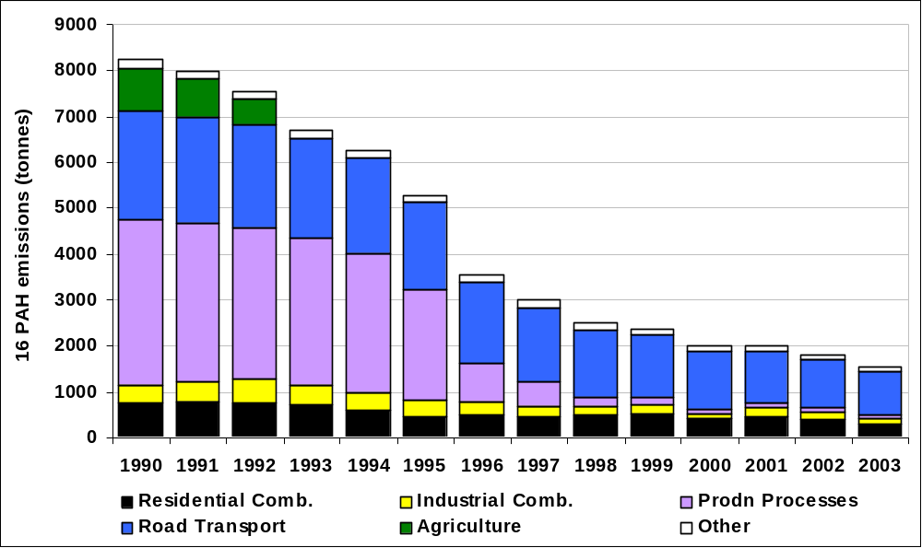
Table 6.4b UK Emissions of BaP³ by UN/ECE Source Category (tonnes)
 | 1990 | 1995 | 1996 | 1997 | 1998 | 1999 | 2000 | 2001 | 2002 | 2003 | 2003%
BY UN/ECE CATEGORY
Combustion in Energy Prod
Public Power | 0.0 | 0.0 | 0.0 | 0.0 | 0.0 | 0.0 | 0.0 | 0.0 | 0.0 | 0.0 | 0%
Petroleum Refining Plants | 0.0 | 0.0 | 0.0 | 0.0 | 0.0 | 0.0 | 0.0 | 0.0 | 0.0 | 0.0 | 1%
Other Combustion & Trans. | 0.1 | 0.0 | 0.0 | 0.0 | 0.0 | 0.0 | 0.0 | 0.0 | 0.0 | 0.0 | 0%
Combustion in Comm/Res
Residential Plant | 6.1 | 3.4 | 3.6 | 3.4 | 3.6 | 3.9 | 2.9 | 3.3 | 2.9 | 2.0 | 49%
Comm/Agricul Combustion | 0.3 | 0.1 | 0.1 | 0.1 | 0.1 | 0.0 | 0.0 | 0.0 | 0.0 | 0.0 | 0%
Combustion in Industry
Iron & Steel Combustion | 0.1 | 0.0 | 0.0 | 0.0 | 0.0 | 0.0 | 0.0 | 0.0 | 0.0 | 0.0 | 1%
Other Ind. Combustion | 0.1 | 0.1 | 0.1 | 0.1 | 0.1 | 0.1 | 0.1 | 0.1 | 0.1 | 0.1 | 1%
Production Processes
Non-Ferrous Metals | 24.6 | 16.3 | 5.2 | 3.9 | 2.6 | 1.5 | 0.7 | 0.7 | 0.7 | 0.2 | 6%
Processes in Industry | 0.2 | 0.1 | 0.1 | 0.1 | 0.1 | 0.1 | 0.1 | 0.1 | 0.1 | 0.1 | 2%
Solvent Use | 0.1 | 0.1 | 0.0 | 0.0 | 0.0 | 0.0 | 0.0 | 0.0 | 0.0 | 0.0 | 1%
Road Transport
Combustion | 5.4 | 2.1 | 1.7 | 1.4 | 1.1 | 0.9 | 0.8 | 0.6 | 0.6 | 0.5 | 12%
Other Trans/Machinery | 0.1 | 0.1 | 0.1 | 0.1 | 0.1 | 0.1 | 0.1 | 0.1 | 0.1 | 0.1 | 2%
Waste | 0.9 | 0.8 | 0.8 | 0.8 | 0.8 | 0.8 | 0.8 | 1.2 | 0.8 | 0.8 | 20%
Agriculture | 28.3 | 0.0 | 0.0 | 0.0 | 0.0 | 0.0 | 0.0 | 0.0 | 0.0 | 0.0 | 0%
Nature | 0.1 | 0.1 | 0.1 | 0.1 | 0.1 | 0.1 | 0.1 | 0.1 | 0.1 | 0.1 | 4%
TOTAL | 66.4 | 23.4 | 12.1 | 10.3 | 8.8 | 7.7 | 5.7 | 6.4 | 5.5 | 4.0 | 100%
3 Benzo[a]pyrene

Figure 6.2 Time Series of Benzo[a]Pyrene Emissions (tonnes)
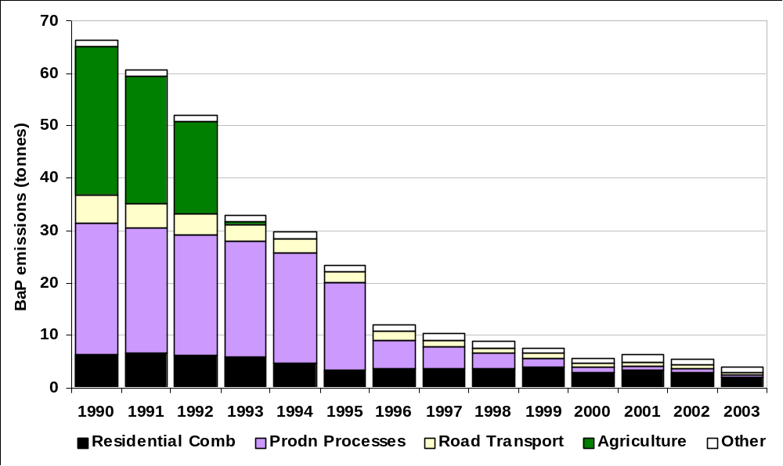

Figure 6.3 Spatially Disaggregated UK Emissions of Benzo[a]pyrene
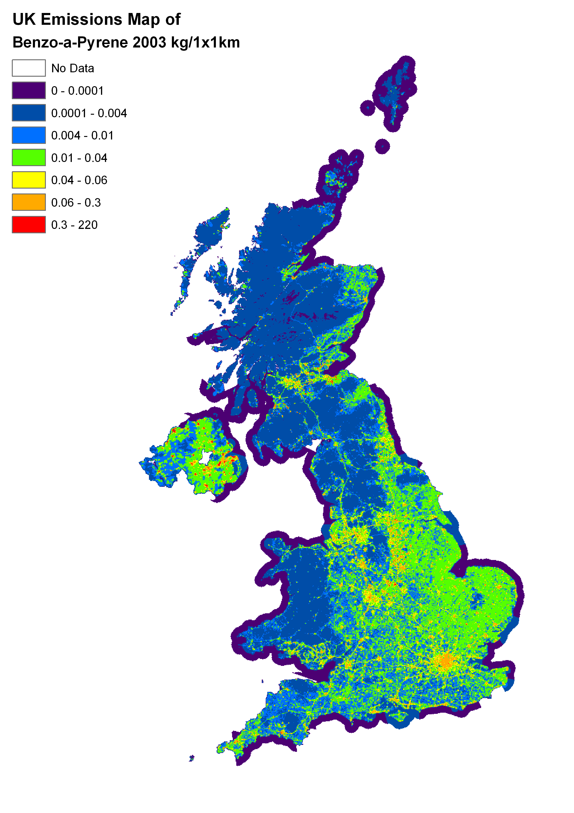

Dioxins and Furans (PCDD/F)
The term “dioxin” is used to refer to the polychlorinated dibenzo-p-dioxins (PCDD) and “furan” is used for polychlorinated dibenzofurans (PCDF). There are 210 PCDD/F compounds in total, which can be described as "congeners"- i.e. different compounds within a family or group having a similar structure. Of these 210 congeners the emissions of importance are those of the 17 PCDD/Fs (7 PCDDs and 10 PCDFs) as defined by the NATO/CCMS (Committee on the Challenges of Modern Society 1988) international toxic equivalent (I-TEQ) scheme. TEQ schemes weight the toxicity of the less toxic congeners as fractions of the toxicity of 2,3,7,8-TCDD, the most toxic congener.

The inventory presented here is in terms of the sum of the weighted emissions expressed as ‘I-TEQs’ which are widely used in UK and European legislation. However, more recently the World Health Organisation (WHO) has suggested a modification to the values used to calculate the toxic equivalents for some of the PCDDs and PCDFs. They have also suggested that there is value in using a similar approach for the PCBs which have dioxin-like toxicity and combining the PCDD/F and PCB TEQs together. The International and the WHO toxic equivalence factors (TEFs) for PCDD/Fs are shown in Table 6.5

Table 6.5 The International and the WHO Toxic Equivalence Factors for PCDD/Fs
(the differences are highlighted)
Dioxins | International TEFs ¹ | WHO TEFs ²
2,3,7,8 tetraetrachlorodibenzo-p-dioxin | 1 | 1
1,2,3,7,8 pentachlorodibenzo-p-dioxin | 0.5 | 1
1,2,3,4,7,8 hexachlorodibenzo-p-dioxin | 0.1 | 0.1
1,2,3,6,7,8 hexachlorodibenzo-p-dioxin | 0.1 | 0.1
1,2,3,7,8,9 hexachlorodibenzo-p-dioxin | 0.1 | 0.1
1,2,3,4,6,7,8 heptachlorodibenzo-p-dioxin | 0.01 | 0.01
Octachlorodibenzo-p-dioxin | 0.001 | 0.0001
Furans
2,3,7,8 tetra4chlorodibenzofuran | 0.1 | 0.1
1,2,3,7,8 pentachlorodibenzofuran | 0.05 | 0.05
2,3,4,7,8 pentachlorodibenzofuran | 0.5 | 0.5
1,2,3,4,7,8 hexachlorodibenzofuran | 0.1 | 0.1
1,2,3,6,7,8 hexachlorodibenzofuran | 0.1 | 0.1
1,2,3,7,8,9 hexachlorodibenzofuran | 0.1 | 0.1
2,3,4,6,7,8 hexachlorodibenzofuran | 0.1 | 0.1
1,2,3,4,6,7,8 heptachlorodibenzofuran | 0.01 | 0.01
1,2,3,4,7,8,9 heptachlorodibenzofuran | 0.01 | 0.01
Octachlorodibenzofuran | 0.001 | 0.0001
¹ NATO/CCMS (1988) ² WHO (1998)

PCDD/Fs have been shown to possess a number of toxicological properties. The major concern is centred on their possible role in immunological and reproductive effects. The main sources of PCDD/Fs are thermal processes, but they can also be released to the environment from some chemical processes.

PCDD/Fs can arise from any thermal process where chlorine is present. For example, coal and other solid fuels contain trace amounts of chlorine compounds which can under certain combustion conditions result in PCDD/F formation. In addition PCDD/Fs can be present in the feedstock material, or chlorinated impurities may be introduced into the feedstock of some thermal processes. The amount of chlorine required for PCDD/F formation may be small and consequently many processes have the potential to emit these pollutants. PCDD/Fs can also be emitted from the chemical production and use of polychlorinated aromatic pesticides and herbicides, many of which are now controlled. However, some chlorinated organic chemicals such as the wood preservative pentachlorophenol are still present in the UK in reservoirs such a treated wood which have the potential on disposal to be sources of PCDD/Fs e.g. from the combustion of the treated wood.

Estimated PCDD/F emissions for 1990-2003 are summarised in Table 6.6 below.

Table 6.6 UK emissions of PCDD/Fs by UN/ECE Source Category (grams TEQ/year)
 | 1990 | 1993 | 1995 | 1996 | 1997 | 1998 | 1999 | 2000 | 2001 | 2002 | 2003 | 2003%
BY UN/ECE CATEGORY
Combustion in Energy Prod
Public Power | 137 | 157 | 182 | 52 | 47 | 22 | 18 | 19 | 20 | 31 | 7 | 3%
Petroleum Refining Plants | 12 | 14 | 14 | 14 | 14 | 14 | 12 | 10 | 11 | 13 | 13 | 5%
Other Combustion & Trans. | 0 | 0 | 0 | 0 | 0 | 0 | 0 | 0 | 0 | 0 | 0 | 0%
Combustion in Comm/Res
Residential Plant | 16 | 16 | 10 | 10 | 9 | 9 | 9 | 7 | 8 | 7 | 4 | 2%
Comm/Agricul Combustion | 99 | 70 | 49 | 32 | 32 | 24 | 24 | 22 | 21 | 14 | 12 | 4%
Combustion in Industry
Iron & Steel Combustion | 48 | 45 | 46 | 45 | 46 | 45 | 42 | 35 | 31 | 24 | 28 | 11%
Non-Ferrous Metals | 40 | 37 | 41 | 42 | 42 | 23 | 18 | 13 | 12 | 11 | 8 | 3%
Other Ind. Combustion | 69 | 68 | 69 | 68 | 65 | 57 | 54 | 49 | 55 | 48 | 51 | 20%
Production Processes
Iron & Steel | 27 | 25 | 26 | 24 | 26 | 23 | 20 | 13 | 13 | 14 | 12 | 5%
Non-Ferrous Metals | 2 | 2 | 2 | 2 | 2 | 2 | 1 | 1 | 1 | 1 | 1 | 0%
Processes in Industry | 4 | 2 | 1 | 1 | 1 | 1 | 1 | 1 | 1 | 1 | 1 | 0%
Solvent Use | 0 | 0 | 0 | 0 | 0 | 0 | 0 | 0 | 0 | 0 | 0 | 0%
Road Transport
Combustion | 29 | 21 | 16 | 15 | 11 | 9 | 6 | 5 | 4 | 3 | 3 | 1%
Vehicle Fires | 5 | 7 | 7 | 7 | 7 | 7 | 8 | 9 | 10 | 10 | 10 | 4%
Other Trans/Machinery | 6 | 6 | 6 | 6 | 5 | 5 | 5 | 4 | 4 | 3 | 2 | 1%
Waste
Landfill | 1 | 1 | 1 | 1 | 1 | 1 | 1 | 1 | 1 | 0 | 0 | 0%
Waste Incineration | 675 | 486 | 319 | 208 | 129 | 101 | 99 | 99 | 99 | 98 | 99 | 38%
Agriculture | 57 | 1 | 0 | 0 | 0 | 0 | 0 | 0 | 0 | 0 | 0 | 0%
Nature | 7 | 7 | 7 | 7 | 7 | 7 | 7 | 7 | 7 | 7 | 7 | 3%
TOTAL | 1232 | 964 | 794 | 533 | 442 | 349 | 327 | 294 | 296 | 285 | 259 | 100%

The largest sources of PCDD/F emission has been, and still is, waste incineration. However emissions from waste incineration have fallen by 80% between 1993 and 2003. This significant trend has been driven by the introduction of control measures. Municipal Solid Waste (MSW) incinerators not meeting the new standards closed in the period leading up to December 1996. Improved combustion and flue gas controls, and developments in abatement technology in modern MSW incinerator design, has resulted in significantly lower levels of PCDD/F emissions.

The relatively low emissions from chemical incinerators reflects the use of rotary kilns and the incorporation of a secondary combustion chamber in the process to destroy organic contaminants together with the relatively low waste throughput and advanced pollution abatement equipment. However, clinical waste incineration remains a significant source. This is due to the fact that emissions from clinical waste incinerators (although showing significant reductions) have not been reducing as rapidly as the total PCDD/F total.

Figure 6.4 Time Series of PCDD/Fs Emissions (grams TEQ)
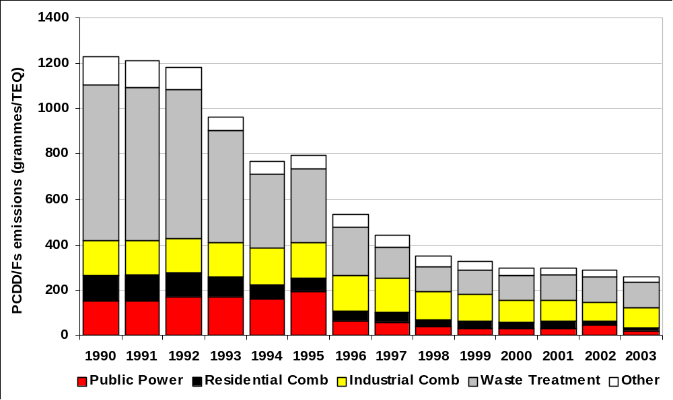

Emissions from power stations are fairly low because the combustion is efficient and the post-combustion fly ash temperatures are rapidly reduced. The emission factors associated with industrial and domestic coal combustion are significantly higher and sum to give a similar contribution, even though the coal consumption is much smaller. However, emissions from all three sectors have decreased with the reduction in the quantity of coal burned.

Emissions from open agricultural burning and accidental fires are included in the agricultural and nature sectors. The former has declined to near zero since the cessation of stubble burning. Accidental fires are currently treated as a source of constant magnitude, and consequently, the percentage contribution from this sector to the total PCDD/F emission has risen as emissions from other significant sectors have decreased.

There are significant emissions from sinter plants owing more to the large gas volumes emitted than to high concentrations. Emissions from iron and steel plants are probably underestimated since only electric arc furnaces are considered. Scrap used in electric arc furnaces and secondary non-ferrous metal production will contain chlorinated impurities such as plastics and cutting oil which contribute to PCDD/F formation.

It is generally accepted that the source of PCDD/F emissions from road transport are the 1,2-dichloroethane scavengers added to leaded petrol. Over recent years both the consumption of leaded petrol, and the lead content of leaded petrol has decreased. Consequently the emissions of PCDD/F from this sector are thought to have decreased. Unleaded petrol and diesel is likely to contain only trace quantities of chlorinated impurities. For 2003, the contribution to the PCDD/F emission total from road transport fuel was 1%.
Figure 6.5 Spatially Disaggregated UK Emissions of PCDD/F
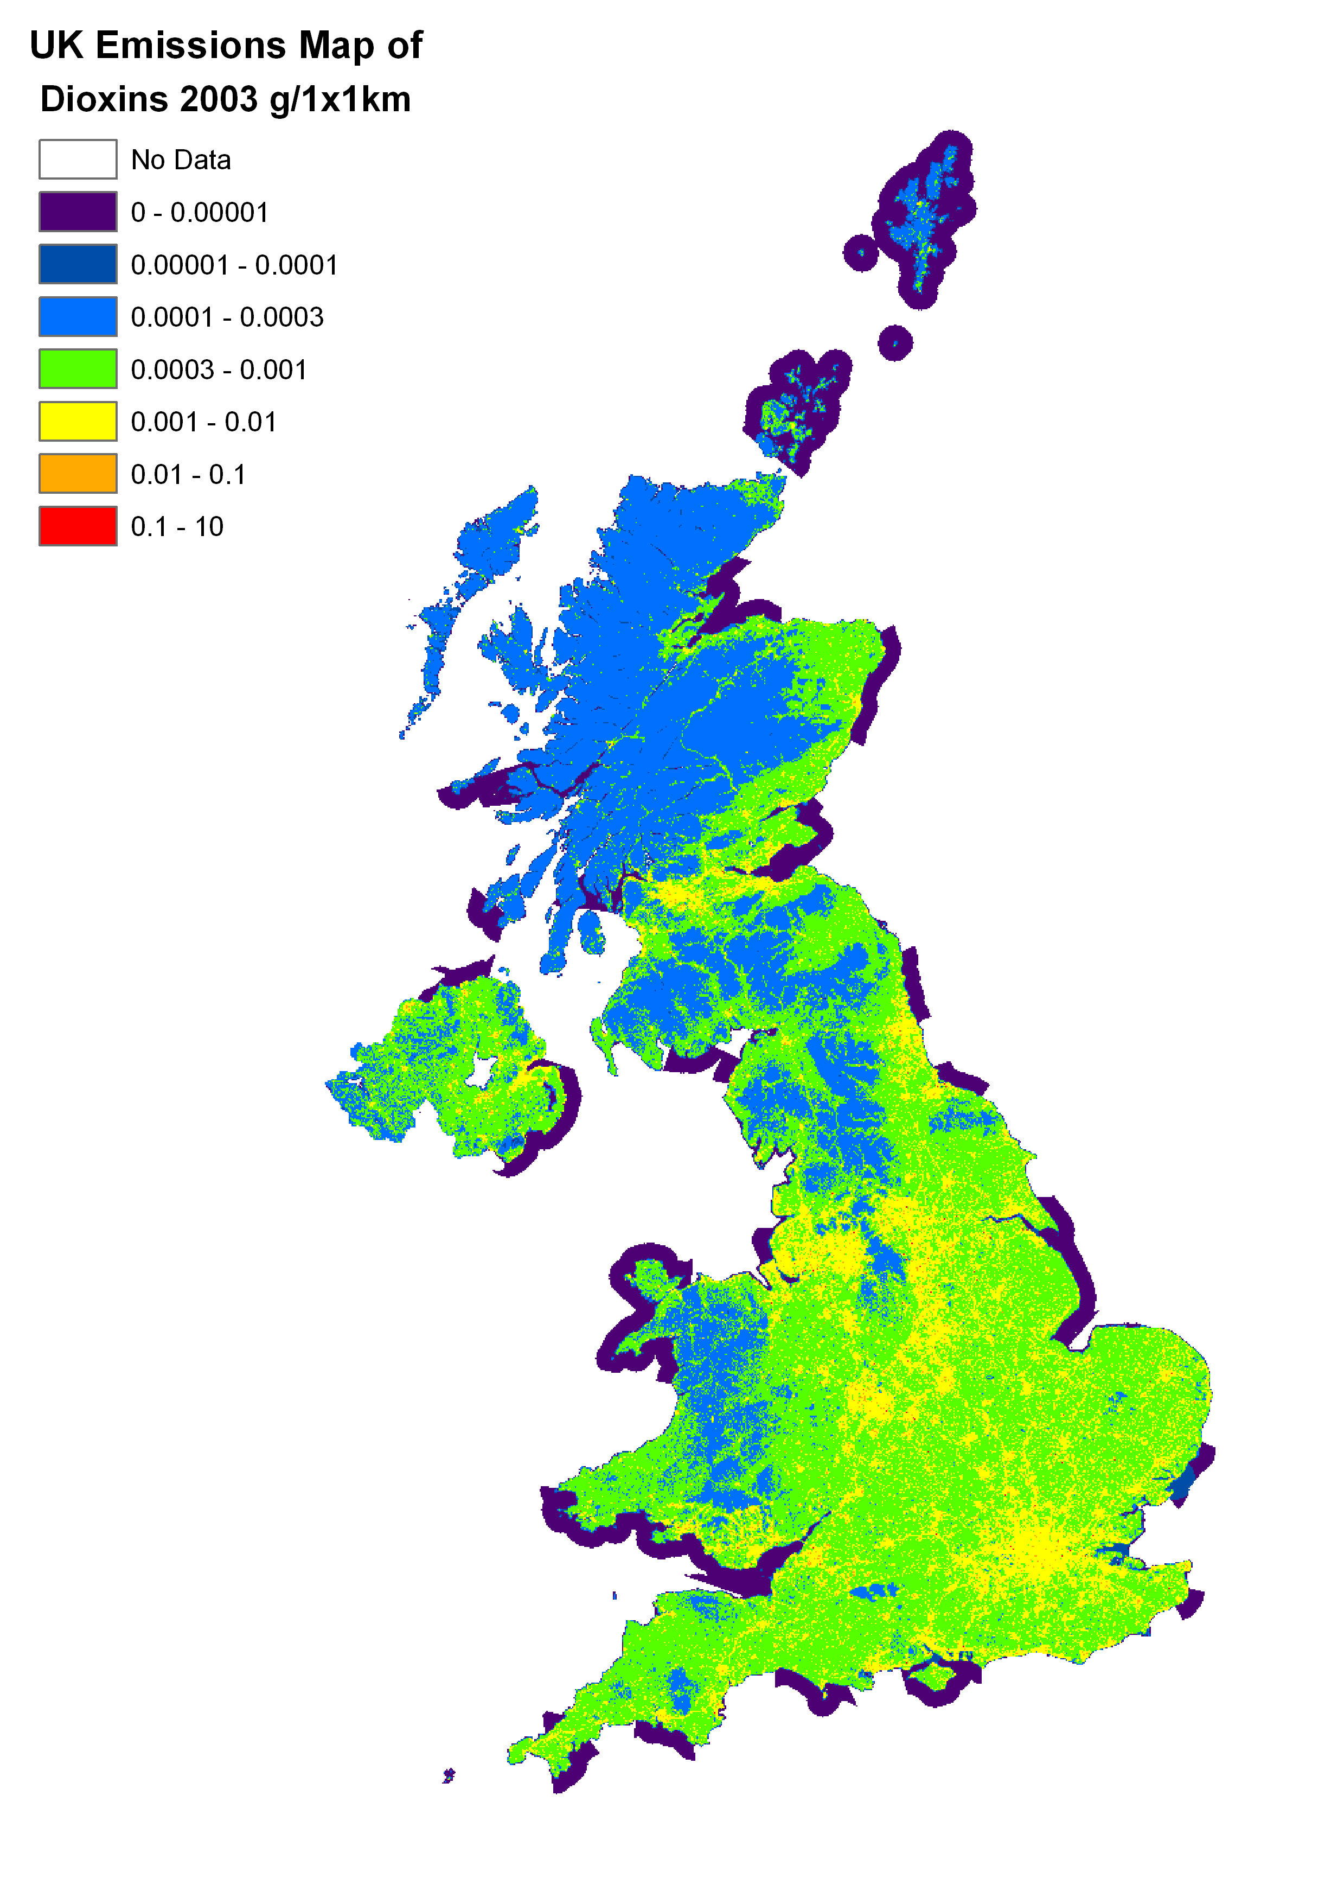

Polychlorinated biphenyls (PCBs)
PCBs are synthetic organic compounds that have mainly been used in electrical equipment as dielectric insulating media.

PCBs have been linked with effects such as reduced male fertility and long-term behavioural and learning impairment. They are classified as probably carcinogenic to humans. Certain PCBs have been assessed as having dioxin-like effects. PCBs are extremely persistent in the environment and possess the ability to concentrate up the food chain. These compounds are highly insoluble in water but accumulate in body fat. Present human exposure is probably dominated by the accumulation through the food chain of the PCBs present in environmental reservoirs such as soils and sediments as a result of previous releases to the environment.

PCBs have not been manufactured and used in the UK for many years, but old equipment containing dielectric fluids (which in turn contain PCBs) still exist. The emissions to air are from equipment still in use leaking, or from destruction of such equipment by using fragmentisers. It is estimated that in 2003, 72% of primary PCB emissions to the atmosphere are associated with such appliances- primarily capacitors and transformers. These emissions primarily arise from in-service appliances; however emissions during disposal are also considered to be significant. Large quantities of PCBs are thought to have been disposed of to landfill in the past, mainly in the form of electrical components or fragmentiser residues, but now such equipment containing PCBs are disposed of by chemical incineration. This process ensures significant reduction in the amount of PCBs being released into the environment. PCBs are also emitted from the soil having previously been deposited there from the air.

PCB speciation has been incorporated into the emission estimates since the 1998 inventory report. A summary of the total PCB emission estimates for 1990 to 2003 is given below in Table 6.7

Table 6.7 – UK Emissions of PCB Emissions by UN/ECE Source Category (kg)
 | 1990 | 1995 | 1996 | 1997 | 1998 | 1999 | 2000 | 2001 | 2002 | 2003 | 2003%
BY UN/ECE CATEGORY
Combustion in Energy Prod
Public Power | 91 | 56 | 51 | 43 | 45 | 39 | 43 | 47 | 44 | 48 | 3%
Other Combustion & Trans. | 10 | 8 | 8 | 8 | 8 | 8 | 8 | 7 | 6 | 6 | 0%
Combustion in Comm/Res |  |  |  |  |  |  |  |  |  |  | 0%
Residential Plant | 22 | 15 | 15 | 13 | 13 | 13 | 11 | 12 | 10 | 7 | 0%
Comm/Agri Combustion | 2 | 1 | 1 | 1 | 1 | 1 | 1 | 1 | 0 | 0 | 0%
Combustion in Industry |  |  |  |  |  |  |  |  |  |  | 0%
Dielectric Fluid | 5911 | 3518 | 3039 | 2560 | 2081 | 1603 | 1124 | 1058 | 992 | 926 | 67%
Other Ind. Combustion | 39 | 37 | 38 | 38 | 37 | 35 | 30 | 29 | 25 | 29 | 2%
Production Processes |  |  |  |  |  |  |  |  |  |  | 0%
Iron & Steel | 496 | 395 | 375 | 398 | 347 | 193 | 188 | 170 | 141 | 141 | 10%
Processes in Industry | 2 | 1 | 1 | 1 | 1 | 1 | 1 | 0 | 0 | 0 | 0%
Waste |  |  |  |  |  |  |  |  |  |  | 0%
Fragmentisers | 317 | 189 | 163 | 137 | 111 | 86 | 60 | 56 | 53 | 49 | 4%
Waste Incineration | 164 | 158 | 158 | 154 | 154 | 154 | 154 | 154 | 154 | 154 | 11%
Other Waste Treat. & Disp. | 82 | 68 | 59 | 49 | 39 | 29 | 21 | 19 | 18 | 17 | 1%
Agriculture | 1 | 0 | 0 | 0 | 0 | 0 | 0 | 0 | 0 | 0 | 0%
TOTAL | 7138 | 4447 | 3908 | 3403 | 2836 | 2161 | 1640 | 1554 | 1444 | 1376 | 100%

Figure 6.6 Time Series of PCBs Emissions (kg)
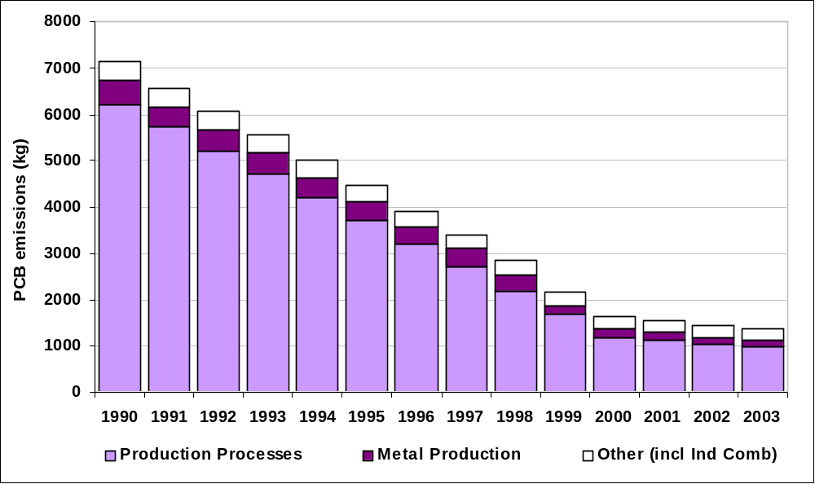

Sales of PCBs in the UK were stopped in 1986. It is thought that they are still manufactured in some countries. The total PCB emission in 1990 was dominated by leaks from capacitors (87% of total emission), and this is the case for 2003.

In 1997 an Action Plan was published by DETR (now Defra) which laid out the commitments made by the UK at the Third International North Sea Conference at the Hague in 1991 in accordance with the requirements of Directive 96/59/EC. These regulations require all PCB holders in the UK to report their stocks to the relevant regulatory bodies. These stocks (except for certain exemptions) were destroyed before the end of December 2000. However, not all electrical equipment containing PCBs is readily identifiable. Emissions from electrical equipment will probably continue, and will only start to fall significantly as the relevant electrical equipment is either destroyed or reaches the end of its working life.

PCBs can be formed in trace amounts from chlorinated precursors in thermal processes such as scrap metal recycling. As a result, there are significant emissions from the iron and steel industrial sector, as with PCDD/Fs.

PCBs occur in sewage sludge due to their persistent nature, and may occur in significant quantities. Not all the PCBs spread on land will volatilise but the potential for emissions to air is greater than that of landfill. The emission estimate comprises only 1% of the total and is highly uncertain. Emissions arise from waste incineration and refuse-derived fuel production resulting from the PCB content of the waste.

Pesticide Emissions
Although there is little available information to enable accurate estimates of pesticide emissions to air, the emission estimates presented here follow from significant improvements to the earlier emission estimates first made in 1996.

Despite these improvements, the confidence in the accuracy of these estimates is low. Relevant data is currently scarce with the majority of emission factors coming from the USA or Europe. The emission factors used here have been derived for a particular method of pesticide application (during specific atmospheric conditions), which may not be representative of the situation in the UK. Until further data become available it is difficult to reduce the uncertainty associated with these estimates. At present no relevant measurement programmes are known of, and therefore the possibility of acquiring additional data is considered to be poor.

Pesticide emissions to the air occur predominately through three pathways: during manufacture, during application and volatilisation after application. Tables 6.8, 6.9 and 6.10 show the estimated emissions of lindane (γ-HCH), pentachlorophenol (PCP) and hexachlorobenzene (HCB) respectively.

Lindane (γ-HCH)
Acute (short-term) effects caused by the inhalation of lindane consist of irritation of the nose and throat, as well as effects on the blood. Chronic (long-term) effects through inhalation have been associated with effects on the liver, blood, immune and cardiovascular systems.

Lindane is applied as an insecticide, fungicide and used as a wood preservation treatment. Lindane is used in the agriculture, domestic and veterinary sectors. Until 1990 lindane was also used as a remedial wood treatment i.e. in a curative role rather than a preservative/preventative. However, data on quantities used for a remedial wood treatment prior to 1990 are not available.

HCH exists in several isomers, however as a result of regulation in the UK, γ-HCH accounts for more than 99% of the total HCH use. Consequently only the γ isomer has been considered in any detail here. The emission estimates presented in Table 6.8a were made assuming that emissions arise from: the application of γ-HCH, treated wood and agricultural and domestic use. γ-HCH emissions are dominated by emissions from treated wood, contributing 94% to the 2003 total emission. Emissions from wood preserving have fallen since 1990.

Emissions from agricultural pesticide activities account for around 3% of total 2003 γ-HCH emissions. These emissions are based on statistics on the use of pesticides containing lindane, obtained from the Pesticide Usage Survey Group (MAFF, 1991a,b, c; 1992a,b, c, d). The emission factors used are taken from van der Most et al (1989).

Emissions of γ-HCH arising from domestic applications are thought to be comparatively small. However, usage statistics are scarce and were only available for 1988 (DOE, 1989). Emission factors are taken from van der Most et al (1989).

Table 6.8a – UK Emissions of γ-HCH by UN/ECE Source Category (tonnes).
 | 1990 | 1995 | 1996 | 1997 | 1998 | 1999 | 2000 | 2001 | 2002 | 2003 | 2003%
BY UN/ECE CATEGORY
Solvent Use
Treated Wood | 57 | 33 | 30 | 27 | 24 | 22 | 20 | 18 | 16 | 14 | 94%
Wood Preserving | 36 | 10 | 8 | 6 | 5 | 4 | 2 | 1 | 0 | 0 | 0%
Agriculture
Domestic Pesticide Use | 1 | 1 | 1 | 1 | 1 | 1 | 1 | 1 | 1 | 1 | 3%
Agriculture Pesticide | 6 | 6 | 6 | 6 | 6 | 6 | 6 | 3 | 0.4 | 0.4 | 3%
TOTAL | 99 | 50 | 44 | 39 | 35 | 32 | 28 | 22 | 17 | 15 | 100%

Figure 6.7 Times Series of γ-HCH Emissions (tonnes)
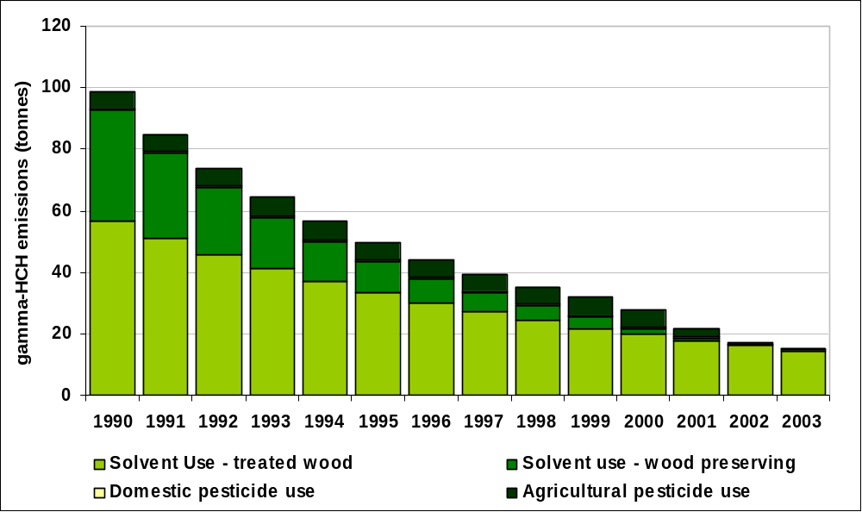

For completeness, the total emissions of HCH are also included here (see Table 6.8b below), although the differences are obscured due to rounding. These total HCH emissions estimates assume the worst case scenario of 1% contribution from non γ isomers to the HCH total.

Table 6.8b – UK Emissions of Total HCH by UN/ECE Source Category (tonnes)
 | 1990 | 1995 | 1996 | 1997 | 1998 | 1999 | 2000 | 2001 | 2002 | 2003 | 2003%
BY UN/ECE CATEGORY
Solvent use | 57 | 34 | 30 | 27 | 25 | 22 | 20 | 18 | 16 | 15 | 94%
Processes in Industry | 36 | 10 | 8 | 6 | 5 | 4 | 2 | 1 | 0 | 0 | 0%
Agriculture
Domestic Pesticide Use | 1 | 1 | 1 | 1 | 1 | 1 | 1 | 1 | 1 | 1 | 3%
Agricultural Pesticide Use | 6 | 6 | 6 | 6 | 6 | 6 | 6 | 3 | 0 | 0 | 3%
TOTAL | 100 | 51 | 45 | 40 | 36 | 32 | 28 | 22 | 17 | 15 | 100%

Pentachlorophenol (PCP)
Pentachlorophenol is associated with both acute and chronic effects on humans through inhalation. Acute effects can lead to eye irritation as well as liver, blood and neurological effects. Chronic exposure can result in effects on the respiratory tract, immune system, liver, kidneys, blood as well as the eyes and nose.

Pentachlorophenol is used as a biocide, and is effective in destroying insect eggs. It is used in the timber and textile industries. The emission estimates given here also include emissions from the use of sodium pentachlorophenoxide (NaPCP) and pentachlorophenyl laureate (PCPL) as well as PCP since these were also included in the proprietary formulations.

The estimated PCP emissions for 1990 to 2003 are given in Table 6.9. The largest percentage contribution to the total PCP emission arises from wood that has been treated within the last 16 years. This accounts for some 94% of the 2003 total PCP emission.

Once again it is very difficult to be certain of these estimates due to the lack of research into emission rates and limited knowledge of quantities used both in the year of the estimate and in previous years. An emission factor of 3% of the wood content per year has been used.

PCP emissions from the textile industry primarily arise from volatilisation during application as a cotton preservative. Emission factors used were based on a study of PCP emissions in the UK (Wild, 1992) reporting that approximately 30% of the applied PCP is lost through volatilisation. Emissions from this sector are comparatively small.

PCP has been used in the agricultural sector as the active ingredient in disinfecting wooden trays used in mushroom farming (classified as solvent use). Usage statistics are reliable coming from the Pesticide Usage Survey Group (MAFF, 1991a,b,c; 1992a,b,c,d). The emission factor assumes 30% loss due to volatilisation (Wild, 1992). Emissions from this sector are comparatively small.

Table 6.9 – UK Emissions of PCP by UN/ECE Source Category (tonnes)
 | 1990 | 1995 | 1996 | 1997 | 1998 | 1999 | 2000 | 2001 | 2002 | 2003 | 2003%
BY UN/ECE CATEGORY
Combustion in Energy Prod | 0.0 | 0.0 | 0.0 | 0.0 | 0.0 | 0.0 | 0.0 | 0.0 | 0.0 | 0.0 | 0%
Combustion in Comm/Res | 0.0 | 0.0 | 0.0 | 0.0 | 0.0 | 0.0 | 0.0 | 0.0 | 0.0 | 0.0 | 0%
Combustion in Industry | 0.0 | 0.0 | 0.0 | 0.0 | 0.0 | 0.0 | 0.0 | 0.0 | 0.0 | 0.0 | 0%
Production Processes | 0.0 | 0.0 | 0.0 | 0.0 | 0.0 | 0.0 | 0.0 | 0.0 | 0.0 | 0.0 | 0%
Solvent Use
Textile Coating | 3.0 | 0.0 | 0.0 | 0.0 | 0.0 | 0.0 | 0.0 | 0.0 | 0.0 | 0.0 | 0%
NaPCP Wood Treatment | 4.0 | 2.0 | 2.0 | 2.0 | 0.0 | 0.0 | 0.0 | 0.0 | 0.0 | 0.0 | 0%
PCP Treated Wood in Use | 474.5 | 458.9 | 451.5 | 444.3 | 437.3 | 430.6 | 424.1 | 417.8 | 411.7 | 411.7 | 94%
PCP Wood Treatment | 6.2 | 0.0 | 0.0 | 0.0 | 0.0 | 0.0 | 0.0 | 0.0 | 0.0 | 0.0 | 0%
PCP in Imported Wood | 50 | 45 | 40 | 35 | 30 | 25 | 25 | 25 | 25 | 25 | 6%
Road Transport | 0.0 | 0.0 | 0.0 | 0.0 | 0.0 | 0.0 | 0.0 | 0.0 | 0.0 | 0.0 | 0%
Other Trans/Machinery | 0.0 | 0.0 | 0.0 | 0.0 | 0.0 | 0.0 | 0.0 | 0.0 | 0.0 | 0.0 | 0%
Waste | 0.0 | 0.0 | 0.0 | 0.0 | 0.0 | 0.0 | 0.0 | 0.0 | 0.0 | 0.0 | 0%
Agriculture | 0.2 | 0.0 | 0.0 | 0.0 | 0.0 | 0.0 | 0.0 | 0.0 | 0.0 | 0.0 | 0%
TOTAL | 538 | 506 | 493 | 481 | 467 | 456 | 449 | 443 | 437 | 437 | 100%

Figure 6.8 Times Series of PCP Emissions (tonnes)
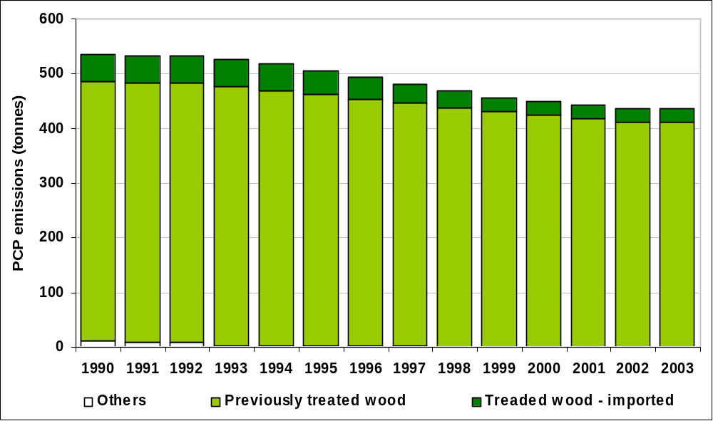

The emission inventory for PCP is very uncertain as only limited emission factors are available on the release of PCP during agricultural activities and statistics are not actively collected on the extent of its usage. There is some data on release of PCP from combustion processes, but the available studies are not consistent with each other suggesting that the uncertainty may be considerable. Without new data becoming available, significant improvements are not expected in the near future.

Hexachlorobenzene (HCB)
Very little information is available on the health effects of HCB via inhalation. However, the lungs may be affected by repeated or prolonged exposure. It is also considered to be a possible carcinogen if long term exposure occurs.

Studies in the USA have identified two main industrial sources of HCB (Mumma et al, 1975) (Jacoff et al, 1986). These are the manufacture of chlorinated solvents (e.g. trichloroethylene, tetrachloroethylene and carbon tetrachloride) and the manufacture of specific pesticides where HCB remains as an impurity. HCB emissions may also arise from combustion sources, but other than waste incineration these could not be estimated, although they are believed to be small.

Statistics for chlorinated solvent production in the UK are commercially confidential, hence estimates were made based on UK solvent usage data from the Solvent Industries Association and import and export statistics.

Although there is no UK manufacture of pesticides that results in the production of HCB, pesticides with HCB as an impurity are still imported and used in the UK for agricultural pest control. Statistics for the use of these pesticides is provided by the Pesticide Usage Survey Group (MAFF, 1991a,b, c; 1992a,b, c, d).

HCB emissions in secondary aluminium smelting result from the use of hexachloroethane (HCE) tablets as a degassing agent (van der Most et al, 1992). Regulations now control the use of HCE and so since 1999, very little secondary aluminium is now melted using HCE. Data on the quantity of degassing agent supplied and the quantity of HCE used per tonne of aluminium melted were obtained from industrial experts and van der Most et al (1989).

Emissions from pesticide application and chlorinated solvent production now account for virtually all of the UK HCB emissions (Table 6.10). For 2003, these two sources are estimated to account for 90% and 9%, respectively, of the total HCB emissions. This represents a change in the relative contributions to the total for 1990 where the same sectors contributed 14% and 17% respectively. This change is a direct result of the reduced emissions from the production of chlorinated solvents, but only very small changes are noted between more recent years.

Table 6.10 – UK Emissions of HCB (kg)
 | 1990 | 1995 | 1996 | 1997 | 1998 | 1999 | 2000 | 2001 | 2002 | 2003 | 2003%
BY UN/ECE CATEGORY
Combustion In Energy Prod | 0 | 1 | 1 | 1 | 1 | 1 | 1 | 1 | 2 | 2 | 1%
Comm/ Public & Agri. Comb | 0 | 0 | 0 | 0 | 0 | 0 | 0 | 0 | 0 | 0 | 0%
Secondary aluminium prod | 2435 | 3881 | 3925 | 4029 | 4292 | 0 | 0 | 0 | 0 | 0 | 0%
Production Processes
Sodium Pentachlorophenoxide | 31 | 6 | 6 | 0 | 0 | 0 | 0 | 0 | 0 | 0 | 0%
Picloram | 0 | 0 | 0 | 0 | 0 | 0 | 0 | 0 | 0 | 0 | 0%
Carbon Tetrachloride | 360 | 0 | 0 | 0 | 0 | 0 | 0 | 0 | 0 | 0 | 0%
Tetrachloroethylene Producn. | 90 | 53 | 59 | 20 | 20 | 21 | 20 | 18 | 17 | 16 | 5%
Trichloroethylene Production | 114 | 90 | 82 | 30 | 27 | 26 | 24 | 20 | 17 | 12 | 4%
Waste | 2 | 1 | 1 | 0 | 0 | 0 | 0 | 0 | 0 | 0 | 0%
Agriculture
Pesticides (Chlorothalonil) | 274 | 420 | 449 | 449 | 430 | 439 | 233 | 232 | 250 | 250 | 83%
Pesticides (Chlorthal-dimethyl) | 156 | 96 | 96 | 91 | 83 | 24 | 24 | 19 | 19 | 19 | 6%
Pesticides (Quintozine) | 52 | 2 | 2 | 2 | 2 | 22 | 22 | 23 | 3 | 3 | 1%
TOTAL | 3517 | 4550 | 4622 | 4622 | 4856 | 534 | 326 | 314 | 307 | 302 | 100%

Figure 6.9 Time Series of HCB Emissions (kg)
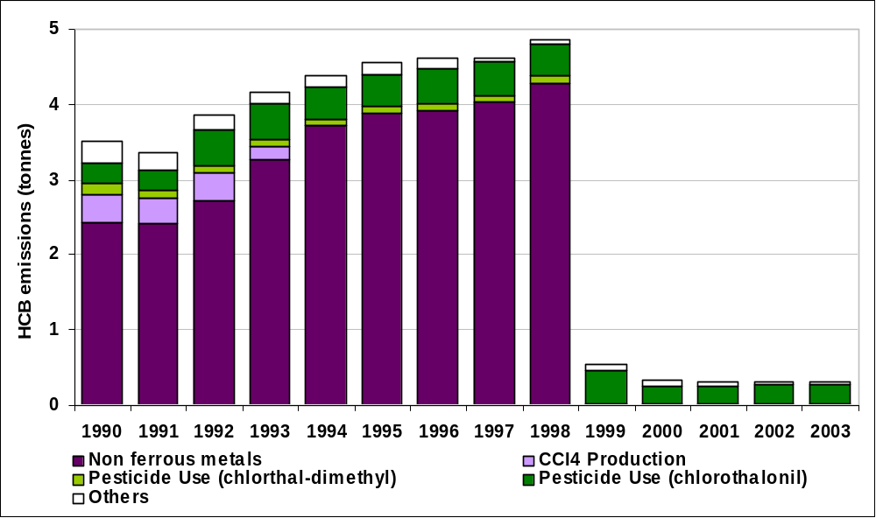

Short Chain Chlorinated Paraffins (SCCP)

Introduction
Short chain chlorinated paraffins (SCCPs) are a range of commercially available chlorinated paraffins with 10-13 carbon atoms. The commercial products are usually mixtures of different carbon chain paraffins with a range of different degrees of chlorination. SCCPs are considered persistent organic pollutants- they do not occur naturally and due to their bioaccumulative and toxicological properties they are of concern to the environment.

Production and Emissions to Air
SCCPs are currently manufactured in the EU and are marketed under a variety of trade names with an average chlorine content of 40-74%. Current consumption in the UK is estimated to be approximately 1000 tonnes per year.

The main uses of SCCPs are in metal working fluids. It has been reported that there are negligible emissions to air of SCCP from production sources, and releases from the majority of industrial consumption results in emissions primarily to water (with very low emissions to air). Emissions from waste water to the atmosphere are unlikely to be large due to the physical properties of SCCPs.

Emission Estimates
Emission estimates have been revised since last years NAEI Report (Goodwin et al, 2002), but this had had little impact on the resulting emission estimates. Current estimates are based on information provided in the European Union Risk Assessment Report (1999) and other data. Emissions of SCCPs have declined considerably since 1990 due to the decrease in consumption caused by a general switch to alternatives.

Table 6.11 UK Emissions of SCCPs (tonnes)
 | 1990 | 1995 | 1996 | 1997 | 1998 | 1999 | 2000 | 2001 | 2002 | 2003
TOTAL | 47 | 24 | 18 | 13 | 8 | 6 | 3 | 0.2 | 0.2 | 0.2

Polychlorinated Napthalenes (PCN)

Introduction
Polychlorinated Napthalenes (PCNs) are a group of 75 theoretically possible chlorinated naphthalenes containing between one and eight chlorine atoms. Their chemical structure is similar to that of PCBs. PCNs are widely considered be associated with cancer and chronic liver disease.

PCNs have been used in a variety of industries. The most important uses are cable insulation, wood preservation, engine oil additives, electroplating masking compounds, feedstock for dye production, dye carriers, capacitors and refractive testing oils.

PCNs have been produced in a number of countries including the UK, USA and France, their synonyms and trade names include Halowax, Nibren waxes, Seekay Waxes, Cerifal Materials and N-Oil. The majority of production generates a standard mixture of the different PCN congeners.

Production and Consumption
A number of assumptions give an estimate of the world-wide PCN production as 150,000 tonnes. Similar assumptions can be made to estimate the UK production as 6,650 tonnes.

6.2.6.3 Emission Estimates
There is very little information concerning the production of PCNs for commercial purposes.
Commercially produced PCNs are thought to be the most important source of PCNs in the atmosphere with the other source sectors being thermal sources, other industrial processes and contamination in PCB industrially produced mixtures.

PCNs have not been produced in the UK for over 30 years and therefore the major releases that were present during their extensive use have decreased. The potential sources are expected to be dominated by the disposal routes of capacitors and engine oil (this is where the majority of the PCNs produced are thought to have been used). Another potential source of PCNs may be the incineration industry, PCNs have been found in fly ash and flue gas in waste incinerators. Landfills are also expected to be a source of PCN emissions.

PCNs have been found in emissions from incinerators and are thought to be produced from the combustion of PAHs. Therefore PCNs could in theory be produced from other high temperature combustion processes. A full review of emission measurements from such processes would be required prior to ascertaining the scale of the emissions of PCNs from such a potentially large array of sources.

As the information regarding the emission of PCNs in the UK is relatively sparse, it is not currently realistic to quote an emission estimate for PCNs. It is hoped that data will become available to resolve this in the future. However, at this time, no programmes are known of which would provide the data required to help with the generation of PCN emissions.

Polybrominated Diphenyl Ethers (PBDEs)

Introduction
There are 209 possible congeners of polybrominated diphenyl ethers (PBDEs). Concern about potential risks to human health and the environment has centred on the potential toxicity, persistence and the tendency for bioaccumulation of some brominated diphenyls.

Since the 1960s, PBDEs have been added as flame-retardants. They are used in a variety of materials (Strandman et al. 2000), including thermoplastics (e.g. high-impact polystyrene) that are used in electrical equipment, computer circuit boards, casings, upholstery, furnishings; interiors in cars, buses, trucks and aeroplanes, rugs, drapery and building materials.

Production and Releases to Air
The annual EU production of polybrominated diphenyl ethers has been estimated to be 11,000 tonnes per year. It has been reported (EU 2000) that the UK used up to 2,000 tonnes of polybrominated biphenyl in 1994. Production of the three commercial mixtures (penta-, octa- and deca-dibrominated diphenyl) has virtually ceased in the EU.

The possible routes of release of PBDEs vary from production to the disposal of the materials for which they are used. There is limited information concerning the releases and it is difficult to attempt to estimate an emission inventory without any measurements of releases from sources or potential sources. Attempts have been made to gather UK usage information. However, information is not easily accessible, particularly as PBDEs are a material used in such a wide variety of industries.

Emission Estimate
It has not been possible to obtain UK specific emission data for PBDEs, but an estimate of the UK emission of PBDEs has been made using the total EU estimate. This is done by scaling with population. Without further assessment of the potential emissions from materials such as plastic and upholstery during production use and disposal it is not possible to make a more accurate estimate. The resulting UK emission estimate for PBDE’s is 7.3 tonnes (Penta-BDE: 2.2t, Octa-BDE: 0.4t, Deca-BDE: 4.7t) per year.

There are a number of improvements that can be made to the UK emission estimate. Resources will be focussed on the following aspects of production and use of secondary products that contain PBDEs.
- Emission from manufacturing sites
- Releases from materials during use
- Release from materials during and following disposal

Accuracy of Emission Estimates of POPs
Quantitative estimates of the uncertainties in emission inventories have been based on calculations made using a direct simulation technique, which corresponds to the IPCC Tier 2 approach recommended for greenhouse gases and also the methodology proposed in draft guidance produced by the UN/ECE Taskforce on Emission Inventories and Projections. This work is described in detail by Passant (2002b). The uncertainty estimates are shown below in Table 6.12.

Table 6.12 Uncertainty of the Emission Inventories for persistent organic pollutants
Pollutant | Estimated Uncertainty %
Benzo[a]pyrene | -70 to +200
Dioxins and furans | -50 to +100
Polychlorinated biphenyls | -40 to + 70
Pentachlorophenol | -80 to +200
Hexachlorohexane | -80 to +300
Hexachlorobenzene | -70 to +200
Short-chain chlorinated paraffins | -90 to +1000
Pentabromodiphenyl ether | -90 to +1000
Polychlorinated naphthalenes | not estimated

Inventories for persistent organic pollutants are more uncertain than those for gaseous pollutants, PM₁₀, and metals. This is largely due to the paucity of emission factor measurements on which to base emission estimates, coupled with a lack of good activity data for some important sources. The inventories for polychlorinated biphenyls and short chain chlorinated paraffins are less uncertain than those for other persistent organic pollutants due to the fact that these pollutants are released to air during their use as products and that reasonably robust data are available on the levels of usage. The uncertainty in emission estimates for polychlorinated naphthalenes has not been estimated since no emission estimates are made.

Heavy metal emission estimates

Introduction
The NAEI currently reports emissions of thirteen metals. These are:

- Arsenic • Mercury
- Beryllium • Nickel
- Cadmium • Selenium
- Chromium • Tin
- Copper • Vanadium
- Lead • Zinc
- Manganese

Emissions inventories for all of the above except beryllium, manganese, selenium, tin, and vanadium were reported by Leech (1993), Gillham et al (1994) and Couling et al (1994). Emissions of all metals except beryllium, manganese and tin were reported by Salway et al (1996, 1996a, 1997) and Goodwin et al (1999, 2000, 2001). Emission estimates for beryllium, manganese, and tin were reported for the first time in the 2000 version of the NAEI (Goodwin et al 2002).

Heavy metal emissions arise from a number of different sources, but in general fuel combustion and certain industrial processes that produce dust are the main contributors. Metal emissions arise from the trace concentrations in the fuels or in the case of industrial processes, the raw materials. In the case of combustion, metals are emitted either as vapour or particulate matter or both. Volatile metals such as mercury and selenium are mostly emitted as vapour. Metals such as cadmium and lead are emitted as both with some of the vapour condensing onto the ash particles. Other metals such as chromium do not vaporise and may be emitted in the ash particles.

Emission estimates for combustion sources are generally based on emission factors developed from fuel composition data, applied to fuel consumption statistics (DTI, 2004). Emission estimates for industrial processes are generally based on data taken from the Pollution Inventory or based on the use of emission factors and activity data taken from the literature. The methodology for industrial process emissions has recently been reviewed (Passant et al, 2002a) and numerous changes have been made. The emissions estimates presented here are based on a recent review of the methodology used for the combustion related sources.

UK data is used for the metal contents of coal and fuel oils where available. Emissions from the combustion of liquid fuels are based on data reported by Wood (1996) and other sources in the literature (Sullivan, 1991; Lloyds 1995). Lead emissions from petrol combustion are based on detailed data on the lead content of petrol published by the Institute of Petroleum (1999). The emissions from coal and oil fired power stations are based on estimates reported in the Pollution Inventory (Environment Agency, 2003) or the operators’ annual reports. Emissions from other coal combustion sources follow the PARCOM methodology (van der Most, 1992) but use data based on UK coal (Smith, 1987). Many of the emission factors for industrial processes such as iron & steel, primary lead/zinc manufacture, secondary copper and cement manufacture are based on data given in the Pollution Inventory, although literature-based emission factors are also used (sources include Clayton et al, (1991), EMEP/CORINAIR(1996), van der Most (1992), Jockel and Hartje (1991), and Smyllie (1996). Details of the methodology are given in Passant et al, (2002a). Emissions from the chloralkali industry are based on manufacturers estimates (Ratcliffe, 1999).

Heavy metal emissions can be reduced using gas cleaning equipment which removes particulates from waste gases. This abatement equipment can be fitted to large coal-fired industrial boilers and power station boilers and also industrial processes which produce large amounts of dust. Hence, when estimating emission factors it is often necessary to assume some efficiency of abatement.

The majority of the emission factors used in generating emission estimates are based on the mass of metal emitted per unit mass of fuel burnt, or mass of metal emitted per unit mass of product for processes. These emission factors are assumed not to vary with time for many of the sources considered. This is assumed as there is usually insufficient information to estimate any temporal variation of the emission factor. However, for sources such as road transport, chlorine production, waste incineration and public power generation, there is sufficient information to allow time dependent emission factors to be estimated.

At the end of 1996 all municipal solid waste and clinical incinerators had to comply with new emission standards (see also Section 6.2.2). As a result, a number of old incinerators have closed, whilst some have been renovated and some new ones opened. Hence there have been significant reductions in emissions from waste incineration. Data is available for most metals for the new plant (Environment Agency, 2003).

In 1984 the miners strike lead to a significant decrease in the use of coal for combustion in electricity generation, industry and the domestic sector. During this period there was an increased use of petroleum products. This fuel switching had a significant impact on the emissions of numerous pollutants, which can be seen in the following time series plots.

Emissions of Arsenic
Acute exposure to high levels of arsenic via the inhalation of dust or fumes leads to gastrointestinal effects such as nausea, diarrhoea and abdominal pain. Chronic inhalation exposure to inorganic arsenic is associated with irritation of the mucous membranes as well as being strongly associated with lung cancer.

Table 6.13 and Figure 6.10 summarise the UK emissions of arsenic. Emissions have declined by 78% since 1970. Historically the largest source of emission was coal combustion with other sources being very small by comparison. Coal use has declined over the period considered, in favour of natural gas use. The emissions from the industrial sector are typically large compared with the emissions from public power generation; this is due to the different levels of abatement efficiency that are assumed. As coal combustion has declined, the use of “CCA” treated wood (the preservative contains Copper, Chromium and Arsenic) as fuel in the industrial sector has become increasingly important- to the extent that it is now the most significant component of Arsenic emissions. The emissions from this source are particularly uncertain because the amount of treated wood used as a fuel source is not well characterised.

Table 6.13 UK Emissions of Arsenic by UN/ECE Category and Fuel (tonnes)
 | 1970 | 1980 | 1990 | 1996 | 1997 | 1998 | 1999 | 2000 | 2001 | 2002 | 2003 | 2003%
BY UN/ECE CATEGORY¹
Combustion in Energy Prod
Public Power | 18.2 | 19.2 | 18.2 | 9.2 | 6.1 | 6.1 | 5.4 | 4.3 | 2.7 | 1.2 | 1.4 | 9%
Petroleum Refining Plants | 1.3 | 1.3 | 0.9 | 1.0 | 1.0 | 1.1 | 0.9 | 0.8 | 0.9 | 1.0 | 0.9 | 6%
Other Comb & Trans | 2.5 | 0.9 | 0.2 | 0.0 | 0.0 | 0.0 | 0.0 | 0.0 | 0.0 | 0.0 | 0.0 | 0%
Combustion in Comm/Res
Residential Plant | 12.2 | 5.5 | 2.8 | 1.8 | 1.6 | 1.5 | 1.5 | 1.2 | 1.4 | 1.2 | 0.7 | 4%
Comm/Agricul Combustion | 10.2 | 3.8 | 2.4 | 1.2 | 1.1 | 0.8 | 0.7 | 0.5 | 0.5 | 0.3 | 0.3 | 2%
Combustion in Industry
Iron & Steel Combustion | 6.8 | 2.9 | 2.2 | 1.2 | 1.0 | 0.7 | 0.5 | 0.3 | 0.3 | 0.3 | 0.3 | 2%
Non-Ferrous Metals | 2.7 | 2.0 | 1.9 | 1.6 | 1.4 | 1.3 | 1.1 | 0.8 | 0.3 | 0.4 | 0.1 | 0%
Other Ind. Combustion | 14.1 | 7.6 | 14.3 | 13.4 | 13.1 | 12.8 | 11.7 | 10.7 | 11.1 | 10.8 | 10.8 | 67%
Production Processes
Iron & Steel | 1.9 | 0.9 | 1.5 | 1.5 | 1.6 | 1.5 | 1.4 | 1.1 | 1.0 | 0.9 | 1.0 | 6%
Non-Ferrous Metals | 0.0 | 0.0 | 0.0 | 0.0 | 0.0 | 0.0 | 0.0 | 0.0 | 0.0 | 0.0 | 0.0 | 0%
Processes in Industry | 0.2 | 0.2 | 0.3 | 0.3 | 0.2 | 0.2 | 0.3 | 0.4 | 0.6 | 0.5 | 0.3 | 2%
Other Trans/Machinery | 0.2 | 0.1 | 0.1 | 0.2 | 0.1 | 0.1 | 0.1 | 0.1 | 0.1 | 0.1 | 0.1 | 1%
Waste | 3.4 | 3.4 | 2.7 | 0.8 | 0.1 | 0.1 | 0.1 | 0.1 | 0.2 | 0.0 | 0.2 | 1%
By FUEL TYPE
Solid | 44.9 | 29.2 | 31.6 | 20.6 | 17.7 | 17.5 | 17.0 | 15.4 | 14.2 | 12.1 | 11.7 | 72%
Petroleum | 11.9 | 6.8 | 4.2 | 2.7 | 2.1 | 2.0 | 1.6 | 1.3 | 1.5 | 1.5 | 1.6 | 10%
Gas | 0.0 | 0.0 | 0.0 | 0.0 | 0.0 | 0.0 | 0.0 | 0.0 | 0.0 | 0.0 | 0.0 | 0%
Non-Fuel | 16.9 | 11.9 | 11.8 | 8.9 | 7.6 | 6.8 | 5.2 | 3.8 | 3.4 | 3.0 | 2.9 | 18%
TOTAL | 73.7 | 47.9 | 47.5 | 32.2 | 27.3 | 26.3 | 23.8 | 20.6 | 19.1 | 16.7 | 16.1 | 100%
¹ See Annex 1 for definition of UN/ECE Categories

Figure 6.10 Time Series of Arsenic Emission (tonnes)
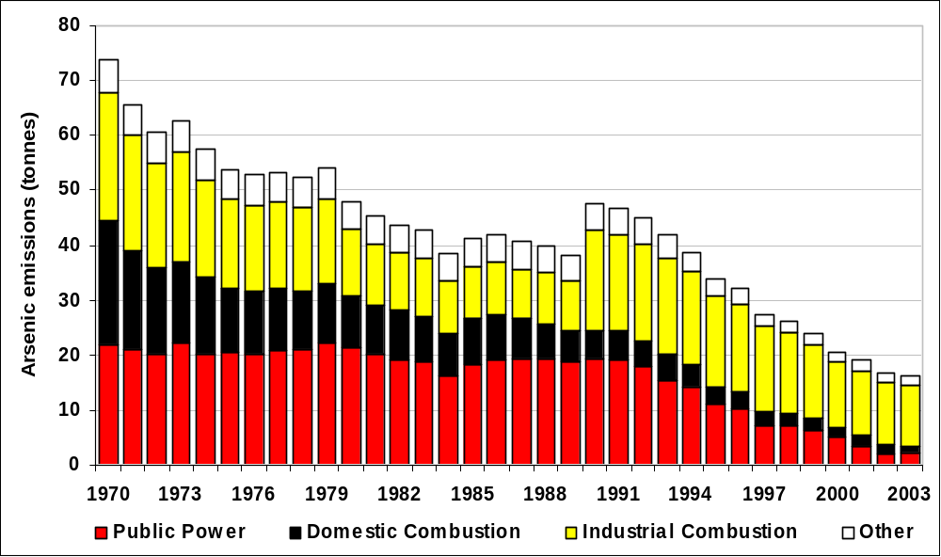

Emissions of Cadmium
Effects of acute inhalation exposure to cadmium consist mainly of effects on the lung, such as pulmonary irritation. Chronic effects via inhalation can cause a build-up of cadmium in the kidneys that can lead to kidney disease.

Table 6.14 and Figure 6.11 summarise the UK emissions of cadmium. Emissions have declined by 87% since 1970. The main sources are energy production, non-ferrous metal production and iron and steel manufacture (as well as other forms of industrial combustion). The emissions for from energy production include a significant proportion from waste combustion and fuel oil combustion for electricity generation. Emissions from non-ferrous metal activities include a lead-zinc smelting plant and a number of lead battery recycling plants.

The decline in emissions is a result of the general fall in coal combustion and the decline in fuel oil combustion in power generation. The large reduction observed from waste emissions is due to improved controls on Municipal Solid Waste (MSW) incinerators from 1993 onwards and their conversion to power generating plant.

Table 6.14 UK Emissions of Cadmium by UN/ECE Category and Fuel (tonnes)
 | 1970 | 1980 | 1990 | 1996 | 1997 | 1998 | 1999 | 2000 | 2001 | 2002 | 2003 | 2003%
BY UN/ECE CATEGORY¹
Combustion in Energy Prod
Public Power | 4.0 | 3.1 | 4.6 | 1.4 | 0.7 | 0.7 | 0.5 | 0.4 | 0.5 | 0.6 | 0.6 | 11%
Petroleum Refining Plants | 2.3 | 2.2 | 1.6 | 1.8 | 1.8 | 1.9 | 1.7 | 1.4 | 1.5 | 1.7 | 1.6 | 30%
Other Combustion & Trans. | 0.1 | 0.0 | 0.0 | 0.0 | 0.0 | 0.0 | 0.0 | 0.0 | 0.0 | 0.0 | 0.0 | 0%
Combustion in Comm/Res
Residential Plant | 1.0 | 0.5 | 0.3 | 0.2 | 0.2 | 0.2 | 0.2 | 0.2 | 0.2 | 0.2 | 0.1 | 3%
Comm/Agricul Combustion | 2.7 | 1.2 | 1.3 | 0.5 | 0.4 | 0.3 | 0.3 | 0.2 | 0.2 | 0.2 | 0.2 | 3%
Combustion in Industry
Iron & Steel Combustion | 6.1 | 2.3 | 1.7 | 1.2 | 1.0 | 0.9 | 0.7 | 0.6 | 0.6 | 0.5 | 0.5 | 9%
Non-Ferrous Metals | 5.0 | 3.5 | 3.6 | 3.0 | 3.4 | 1.5 | 2.0 | 2.5 | 1.0 | 1.4 | 0.3 | 6%
Other Ind. Combustion | 10.3 | 6.1 | 2.8 | 1.8 | 1.5 | 1.3 | 0.9 | 0.8 | 0.9 | 0.9 | 0.9 | 17%
Production Processes
Iron & Steel | 1.1 | 0.7 | 1.0 | 1.0 | 1.0 | 0.9 | 0.8 | 0.7 | 0.6 | 0.5 | 0.5 | 10%
Non-Ferrous Metals | 0.0 | 0.1 | 0.1 | 0.0 | 0.0 | 0.0 | 0.0 | 0.0 | 0.1 | 0.1 | 0.1 | 1%
Processes in Industry | 0.5 | 0.5 | 0.3 | 0.2 | 0.1 | 0.1 | 0.1 | 0.1 | 0.1 | 0.0 | 0.0 | 0%
Road Transport
Combustion | 0.2 | 0.2 | 0.3 | 0.4 | 0.4 | 0.4 | 0.4 | 0.4 | 0.4 | 0.4 | 0.4 | 7%
Brake & Tyre Wear | 0.0 | 0.0 | 0.0 | 0.0 | 0.0 | 0.0 | 0.0 | 0.0 | 0.0 | 0.0 | 0.0 | 1%
Other Trans/Machinery | 0.2 | 0.1 | 0.1 | 0.1 | 0.1 | 0.1 | 0.1 | 0.1 | 0.1 | 0.1 | 0.1 | 1%
Waste | 10.3 | 10.3 | 7.9 | 0.3 | 0.1 | 0.0 | 0.0 | 0.1 | 0.1 | 0.0 | 0.0 | 0%
By FUEL TYPE
Solid | 3.1 | 2.5 | 2.1 | 1.1 | 0.8 | 0.8 | 0.6 | 0.5 | 0.7 | 0.7 | 0.7 | 12%
Petroleum | 18.2 | 10.3 | 5.9 | 4.4 | 3.7 | 3.4 | 2.9 | 2.4 | 2.7 | 2.8 | 2.9 | 54%
Gas | 0.0 | 0.0 | 0.0 | 0.0 | 0.0 | 0.0 | 0.0 | 0.0 | 0.0 | 0.0 | 0.0 | 0%
Non-Fuel | 22.4 | 18.1 | 17.8 | 6.4 | 6.4 | 4.1 | 4.1 | 4.3 | 2.7 | 2.9 | 1.9 | 34%
TOTAL | 43.7 | 30.9 | 25.8 | 11.9 | 10.9 | 8.4 | 7.7 | 7.3 | 6.1 | 6.4 | 5.5 | 100%
¹ See Annex 1 for definition of UN/ECE Categories

Figure 6.11 Time Series of Cadmium Emissions (tonnes)
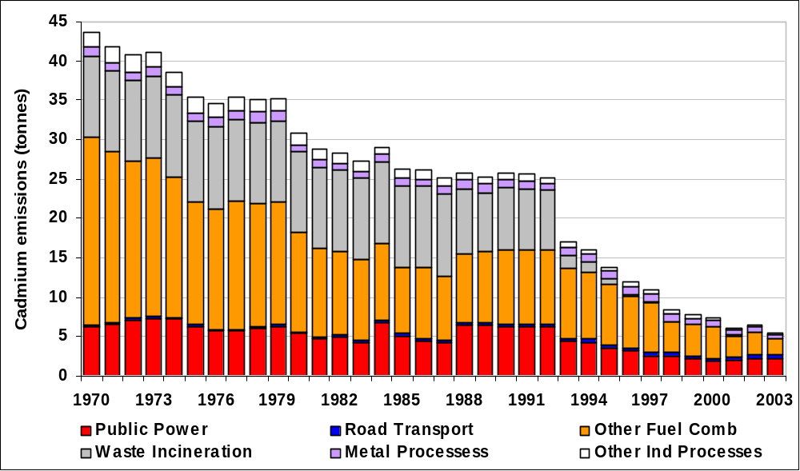

Emissions of Chromium
Inhaled chromium is a carcinogen, leading to an increased risk of lung cancer. Acute exposure effects can result in shortness of breath, coughing and wheezing, whilst chronic exposure effects lead to perforation and ulceration of the septum, bronchitis, pneumonia, and decreased pulmonary function.

Table 6.15a and Figure 6.12 summarise the UK emissions of chromium. Emissions have fallen by 82% since 1970. The largest sources are various forms of coal combustion, iron and steel production in integrated works and in electric arc furnaces and the production of chromium-based chemicals. More recently as other process emissions have decreased, the emissions from burning “CCA” treated wood in industry as a fuel have become a relatively more important source (see Section 6.4.2).

Table 6.15a UK Emissions of Chromium by UN/ECE Category and Fuel (tonnes)
 | 1970 | 1980 | 1990 | 1996 | 1997 | 1998 | 1999 | 2000 | 2001 | 2002 | 2003 | 2003%
BY UN/ECE CATEGORY¹
Combustion in Energy Prod
Public Power | 50.3 | 57.5 | 53.1 | 25.7 | 17.2 | 17.0 | 17.4 | 15.1 | 12.0 | 6.9 | 5.7 | 13%
Petroleum Refining Plants | 2.5 | 2.4 | 1.7 | 2.0 | 2.0 | 2.1 | 1.8 | 1.5 | 1.7 | 1.9 | 1.8 | 4%
Other Combustion & Trans. | 0.3 | 0.1 | 0.0 | 0.0 | 0.0 | 0.0 | 0.0 | 0.0 | 0.0 | 0.0 | 0.0 | 0%
Combustion in Comm/Res
Residential Plant | 24.0 | 11.2 | 5.9 | 4.2 | 3.8 | 3.6 | 3.7 | 3.1 | 3.4 | 3.0 | 2.1 | 5%
Comm/Agricul Combustion | 3.8 | 1.6 | 0.9 | 0.7 | 0.5 | 0.4 | 0.4 | 0.2 | 0.3 | 0.2 | 0.2 | 1%
Combustion in Industry
Iron & Steel Combustion | 73.7 | 35.3 | 28.1 | 14.9 | 11.8 | 8.7 | 5.6 | 3.6 | 3.4 | 3.0 | 3.0 | 7%
Non-Ferrous Metals | 0.2 | 0.1 | 0.1 | 0.2 | 0.2 | 0.2 | 0.2 | 0.2 | 0.2 | 0.8 | 0.4 | 1%
Other Ind. Combustion | 19.0 | 10.4 | 15.4 | 13.8 | 13.5 | 13.2 | 12.6 | 12.9 | 12.3 | 11.8 | 12.1 | 28%
Production Processes
Iron & Steel | 21.4 | 17.0 | 18.2 | 16.7 | 17.8 | 15.5 | 10.3 | 7.6 | 22.7 | 3.6 | 3.7 | 9%
Non-Ferrous Metals | 0.0 | 0.0 | 0.0 | 0.0 | 0.0 | 0.0 | 0.0 | 0.0 | 0.0 | 0.0 | 0.0 | 0%
Processes in Industry | 40.9 | 41.7 | 36.0 | 27.6 | 30.2 | 29.6 | 24.9 | 30.9 | 17.6 | 14.3 | 13.2 | 30%
Road Transport | 0.5 | 0.6 | 0.9 | 0.9 | 1.0 | 1.0 | 1.0 | 1.0 | 1.0 | 1.0 | 1.0 | 2%
Other Trans/Machinery | 0.3 | 0.1 | 0.1 | 0.2 | 0.1 | 0.1 | 0.1 | 0.1 | 0.1 | 0.1 | 0.1 | 0%
Waste | 0.5 | 0.5 | 0.4 | 0.3 | 0.1 | 0.1 | 0.1 | 0.1 | 0.1 | 0.1 | 0.1 | 0%
By FUEL TYPE
Solid | 76.5 | 69.3 | 68.0 | 38.8 | 30.1 | 29.7 | 30.2 | 27.2 | 24.5 | 18.7 | 16.5 | 38%
Petroleum | 18.7 | 10.6 | 5.8 | 4.7 | 4.0 | 3.7 | 3.2 | 2.7 | 3.0 | 3.2 | 3.3 | 8%
Gas | 0.0 | 0.0 | 0.0 | 0.0 | 0.0 | 0.0 | 0.0 | 0.0 | 0.0 | 0.0 | 0.0 | 0%
Non-Fuel | 142.2 | 98.8 | 87.2 | 63.8 | 64.1 | 58.1 | 44.7 | 46.5 | 47.3 | 24.8 | 23.7 | 55%
TOTAL | 237.3 | 178.7 | 160.9 | 107.2 | 98.3 | 91.6 | 78.1 | 76.4 | 74.8 | 46.6 | 43.5 | 100%
¹ See Annex 1 for definition of UN/ECE Categories

Figure 6.12 Time Series of Chromium Emissions (tonnes)
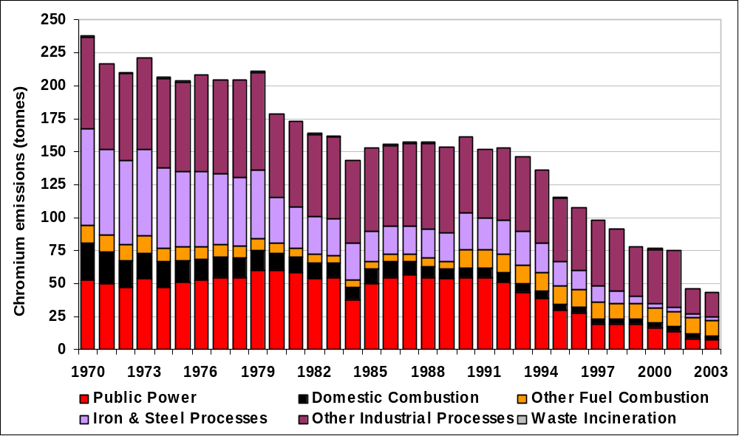

Speciation of Chromium
Chromium may be emitted to air in two oxidised forms - hexavalent (Cr⁶⁺) and trivalent (Cr³⁺). The proportion of each form emitted by each source has been estimated and the overall split between the two forms is shown in Table 6.15b

Table 6.15b Speciated Emissions of Chromium (tonnes)
 | Cr⁶⁺ | Cr³⁺ | Total (2003)
BY UN/ECE CATEGORY
Combustion in Energy Prod. | 0.9 | 6.6 | 7.5
Combustion in Comm/Inst/Res | 0.2 | 2.1 | 2.3
Combustion in Industry | 9.4 | 6.1 | 15.5
Production Processes | 4.2 | 12.7 | 16.9
Road Transport | 0.2 | 0.8 | 1.0
Other Trans/Machinery | 0.0 | 0.1 | 0.1
Waste | 0.0 | 0.1 | 0.1
TOTAL | 14.9 | 28.5 | 43.5

The profiles used for the speciation are based on the recommendations given in Passant et al (2002a). In general, these profiles are subject to great uncertainty and further measurement data are required, particularly for major sources such as coal combustion, glass production, electric arc furnaces and chemical processes (other than chromium chemicals for which good data are available).

Emissions of Copper
Acute effects of copper fumes can lead to irritation of the eyes, nose and throat, resulting in coughing, wheezing and nosebleeds. It may also cause 'metal fume fever', which is a flu-like illness that has symptoms of a metallic taste, fever, chill, aches and chest tightness. Chronic exposure may lead to decreased fertility in both men and women. Severe irritation and ulcers in the nose may also occur.

Table 6.16 and Figure 6.13 summarise the UK emissions of copper. Emissions have declined by 70% since 1970. The main sources are coal combustion, public power generation and road transport. Emissions have declined over the period due to the decline in coal combustion and to a lesser extent the combustion of heavy fuel oil. The large reduction in waste emissions is due to improved controls on MSW waste incinerators from 1997 and their conversion to power generating plant.

Table 6.16 UK Emissions of Copper by UN/ECE Category and Fuel (tonnes)
 | 1970 | 1980 | 1990 | 1996 | 1997 | 1998 | 1999 | 2000 | 2001 | 2002 | 2003 | 2003%
BY UN/ECE CATEGORY¹
Combustion in Energy Prod
Public Power | 39.3 | 44.5 | 41.2 | 20.3 | 13.8 | 16.6 | 13.0 | 14.0 | 10.6 | 4.9 | 4.6 | 7%
Petroleum Refining Plants | 3.1 | 3.0 | 2.2 | 2.4 | 2.5 | 2.6 | 2.3 | 1.9 | 2.0 | 2.3 | 2.2 | 3%
Other Combustion & Trans. | 10.5 | 3.6 | 0.6 | 0.0 | 0.0 | 0.0 | 0.1 | 0.1 | 0.0 | 0.0 | 0.0 | 0%
Combustion in Comm/Res
Residential Plant | 5.9 | 2.8 | 1.5 | 1.1 | 1.0 | 0.9 | 0.9 | 0.8 | 0.9 | 0.8 | 0.6 | 1%
Comm/Agricul Combustion | 40.5 | 15.4 | 9.2 | 4.5 | 4.6 | 3.2 | 2.8 | 2.3 | 2.2 | 1.3 | 1.0 | 2%
Combustion in Industry
Iron & Steel Combustion | 25.2 | 12.7 | 12.0 | 9.8 | 9.3 | 8.2 | 7.0 | 6.4 | 6.4 | 5.7 | 5.8 | 9%
Non-Ferrous Metals | 41.1 | 32.2 | 25.6 | 18.7 | 15.3 | 11.2 | 11.1 | 6.7 | 4.2 | 6.1 | 3.6 | 5%
Other Ind. Combustion | 22.1 | 13.2 | 13.5 | 12.6 | 12.3 | 11.5 | 10.6 | 11.1 | 11.0 | 10.5 | 11.1 | 17%
Production Processes
Iron & Steel | 10.2 | 5.1 | 7.8 | 7.7 | 8.0 | 7.5 | 6.7 | 6.1 | 5.2 | 4.6 | 5.3 | 8%
Non-Ferrous Metals | 0.0 | 0.0 | 0.0 | 0.0 | 0.0 | 0.0 | 0.0 | 0.1 | 0.1 | 0.1 | 0.2 | 0%
Processes in Industry | 2.1 | 2.5 | 3.6 | 12.4 | 4.8 | 4.9 | 4.4 | 4.5 | 2.4 | 2.3 | 2.4 | 4%
Road Transport | 12.7 | 16.1 | 21.3 | 22.6 | 22.9 | 23.3 | 23.6 | 23.6 | 23.9 | 24.5 | 24.8 | 38%
Other Trans/Machinery | 1.1 | 0.9 | 0.9 | 0.9 | 0.8 | 0.8 | 0.7 | 0.7 | 0.6 | 0.5 | 0.6 | 1%
Waste | 2.5 | 2.5 | 2.3 | 0.9 | 0.2 | 0.3 | 0.3 | 0.3 | 0.2 | 0.1 | 0.1 | 0%
Other (Fireworks) | 2.8 | 2.8 | 2.8 | 2.8 | 2.8 | 2.8 | 2.8 | 2.8 | 2.8 | 2.8 | 2.8 | 4%
By FUEL TYPE
Solid | 94.1 | 64.0 | 56.0 | 29.4 | 23.3 | 24.5 | 21.0 | 21.4 | 18.4 | 11.5 | 10.8 | 16%
Petroleum | 26.0 | 16.3 | 9.5 | 8.0 | 7.2 | 6.8 | 6.0 | 5.3 | 5.8 | 5.7 | 5.9 | 9%
Gas | 0.0 | 0.0 | 0.0 | 0.0 | 0.0 | 0.0 | 0.0 | 0.0 | 0.0 | 0.0 | 0.0 | 0%
Non-Fuel | 99.1 | 77.2 | 78.9 | 79.3 | 67.9 | 62.4 | 59.3 | 54.7 | 48.3 | 49.4 | 48.6 | 74%
TOTAL | 219.2 | 157.5 | 144.4 | 116.7 | 98.4 | 93.7 | 86.3 | 81.4 | 72.4 | 66.6 | 65.2 | 100%
¹ See Annex 1 for definition of UN/ECE Categories

Figure 6.13 Time Series of Copper Emissions (tonnes)
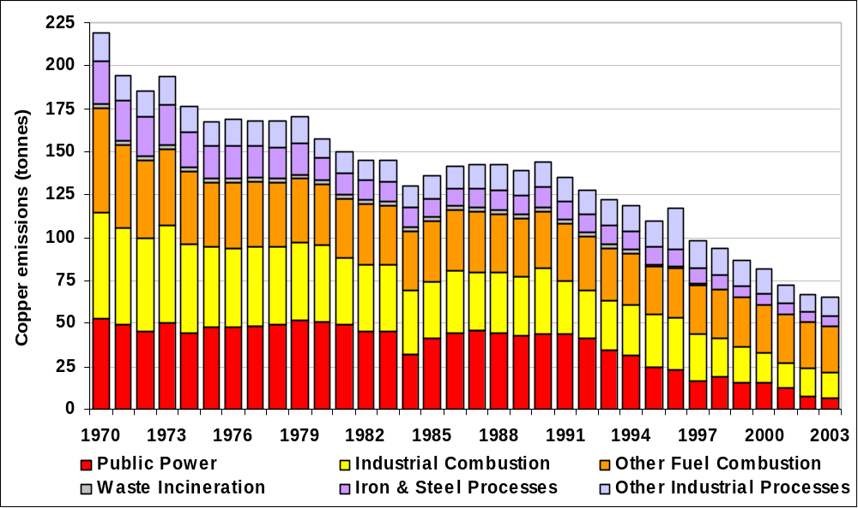

Emissions of Lead
Lead is a very toxic element and can cause a variety of symptoms at low dose levels. Lead dust or fumes can irritate the eyes on contact, as well as causing irritation to the nose and throat on inhalation. Acute exposure can lead to loss of appetite, weight loss, stomach upsets, nausea and muscle cramps. High levels of acute exposure may also cause brain and kidney damage. Chronic exposure can lead to effects on the blood, kidneys, central nervous system and vitamin D metabolism.

Table 6.17 and Figure 6.14 summarise the UK emissions of lead. Emissions have declined by 98% since 1970. The largest source was lead from anti-knock lead additives in petrol. The lead content of leaded petrol was reduced from around 0.34 g/l to 0.143 g/l in 1986 and since 1987 sales of unleaded petrol have increased particularly as a result of the increased use of cars fitted with catalytic converters. Leaded petrol was then phased out from general sale at the end of 1999. Consequently a decline in emissions from the road transport sector is seen.

Other major sources are industrial processes and iron and steel combustion. There has been some reduction in emissions from iron and steel production processes due to improved abatement measures. Emissions have also declined as a result of the decreasing use of coal. The large reduction in waste emissions is due to improved controls on MSW incinerators from 1997 onwards.

Table 6.17 UK Emissions of Lead by UN/ECE Category and Fuel (tonnes)
 | 1970 | 1980 | 1990 | 1996 | 1997 | 1998 | 1999 | 2000 | 2001 | 2002 | 2003 | 2003%
BY UN/ECE CATEGORY¹
Combustion in Energy Prod
Public Power | 81.6 | 88.5 | 132.7 | 88.5 | 57.0 | 26.6 | 17.1 | 18.4 | 15.0 | 12.2 | 14.1 | 11%
Petroleum Refining Plants | 2.4 | 2.4 | 1.7 | 1.9 | 1.9 | 2.0 | 1.8 | 1.5 | 1.6 | 1.8 | 1.8 | 1%
Other Combustion & Trans. | 9.2 | 3.2 | 0.6 | 0.0 | 0.0 | 0.0 | 0.0 | 0.1 | 0.0 | 0.0 | 0.0 | 0%
Combustion in Comm/Res
Residential Plant | 106.7 | 62.1 | 23.7 | 14.5 | 12.9 | 11.8 | 11.2 | 8.3 | 9.3 | 7.9 | 5.0 | 4%
Comm/Agricul Combustion | 35.0 | 13.3 | 30.5 | 11.5 | 5.0 | 2.7 | 2.4 | 2.0 | 1.9 | 1.1 | 0.9 | 1%
Combustion in Industry
Iron & Steel Combustion | 234.1 | 105.1 | 110.8 | 81.1 | 74.6 | 66.3 | 56.7 | 47.4 | 43.3 | 37.8 | 44.0 | 33%
Non-Ferrous Metals | 67.4 | 48.5 | 47.9 | 37.5 | 34.5 | 26.0 | 24.9 | 23.8 | 26.4 | 29.6 | 11.9 | 9%
Other Ind. Combustion | 154.8 | 100.8 | 42.1 | 33.7 | 32.2 | 28.5 | 25.5 | 23.0 | 23.1 | 25.4 | 23.2 | 17%
Production Processes
Iron & Steel | 34.8 | 28.0 | 30.4 | 28.0 | 29.7 | 25.8 | 22.6 | 23.0 | 19.7 | 13.9 | 16.0 | 12%
Non-Ferrous Metals | 1.6 | 1.1 | 1.3 | 1.1 | 1.2 | 1.2 | 0.8 | 0.6 | 0.4 | 0.2 | 0.2 | 0%
Processes in Industry | 97.0 | 97.0 | 95.7 | 72.6 | 111.6 | 87.4 | 28.3 | 12.3 | 14.3 | 11.1 | 13.5 | 10%
Road Transport | 6363 | 7445 | 2158 | 895 | 784 | 575 | 302 | 2 | 2 | 2 | 2 | 1%
Other Trans/Machinery | 1.1 | 1.0 | 0.8 | 0.8 | 0.7 | 0.7 | 0.6 | 0.6 | 0.5 | 0.4 | 0.5 | 0%
Waste | 311.4 | 311.4 | 238.1 | 48.9 | 2.4 | 0.7 | 1.2 | 1.2 | 0.2 | 0.2 | 0.2 | 0%
By FUEL TYPE
Solid | 215 | 141 | 108 | 56 | 42 | 41 | 32 | 30 | 29 | 23 | 21 | 16%
Petroleum | 6509 | 7553 | 2187 | 910 | 797 | 585 | 310 | 6 | 7 | 6 | 6 | 5%
Gas | 0 | 0 | 0 | 0 | 0 | 0 | 0 | 0 | 0 | 0 | 0 | 0%
Non-Fuel | 777 | 614 | 619 | 349 | 309 | 229 | 154 | 128 | 123 | 115 | 106 | 79%
TOTAL | 7500 | 8308 | 2914 | 1315 | 1148 | 855 | 495 | 164 | 158 | 144 | 133 | 100%
¹ See Annex 1 for definition of UN/ECE Categories

Figure 6.14 Time Series of Lead Emissions (tonnes)
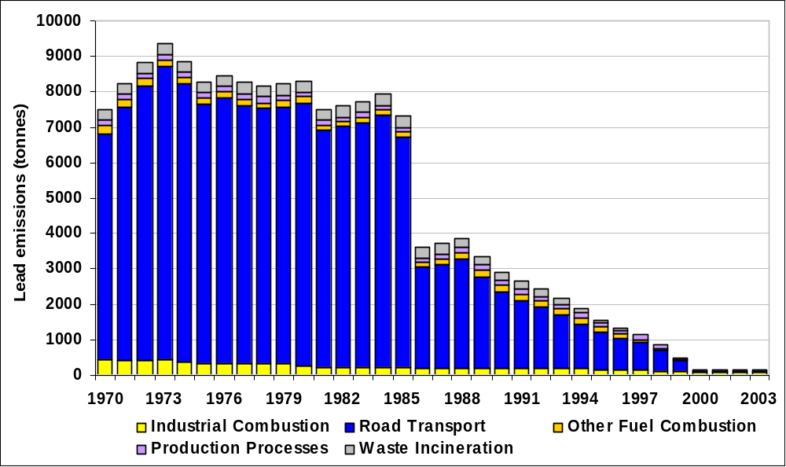

Emissions of Mercury
Acute exposure to high levels of elemental mercury vapour can lead to irritation of the lungs as well as causing coughing, chest pain and shortness of breath. High levels can also result in central nervous system (CNS) effects such as tremors and mood changes. Chronic exposure also leads to CNS disorders, with effects such as increased excitability, excessive shyness and irritability.

Table 6.18a and Figure 6.15 summarise the UK emissions of mercury. Emissions have declined by 88% since 1970. The main sources are waste incineration, the manufacture of chlorine in mercury cells, coal and other forms of industrial combustion. Emissions have declined as a result of improved controls on mercury cells and their replacement by diaphragm or membrane cells and the decline of coal use. The large reduction in waste emissions is due to improved controls on MSW incinerators from 1997 onwards and their conversion to power generating plant.

Table 6.18a UK Emissions of Mercury by UN/ECE Category and Fuel (tonnes)
 | 1970 | 1980 | 1990 | 1996 | 1997 | 1998 | 1999 | 2000 | 2001 | 2002 | 2003 | 2003%
BY UN/ECE CATEGORY¹
Combustion in Energy Prod
Public Power | 7.7 | 8.1 | 8.9 | 2.8 | 2.5 | 2.6 | 1.7 | 1.6 | 1.7 | 1.5 | 1.8 | 24%
Petroleum Refining Plants | 0.1 | 0.1 | 0.1 | 0.1 | 0.1 | 0.1 | 0.1 | 0.1 | 0.1 | 0.1 | 0.1 | 1%
Other Combustion & Trans. | 0.9 | 0.3 | 0.1 | 0.0 | 0.0 | 0.0 | 0.0 | 0.0 | 0.0 | 0.0 | 0.0 | 0%
Combustion in Comm/Res
Residential Plant | 2.9 | 1.3 | 0.7 | 0.4 | 0.4 | 0.4 | 0.4 | 0.3 | 0.3 | 0.3 | 0.2 | 2%
Comm/Agricul Combustion | 3.2 | 1.2 | 1.3 | 0.4 | 0.4 | 0.2 | 0.2 | 0.2 | 0.2 | 0.1 | 0.1 | 1%
Combustion in Industry
Iron & Steel Combustion | 13.0 | 6.1 | 5.1 | 2.9 | 2.4 | 1.8 | 1.3 | 0.9 | 0.8 | 0.7 | 0.8 | 11%
Non-Ferrous Metals | 4.0 | 2.5 | 2.9 | 2.3 | 2.0 | 1.4 | 0.4 | 0.8 | 0.7 | 0.2 | 0.0 | 0%
Other Ind. Combustion | 10.3 | 3.7 | 2.7 | 2.0 | 1.5 | 1.7 | 1.5 | 1.2 | 1.5 | 1.4 | 0.9 | 13%
Production Processes
Iron & Steel | 0.3 | 0.2 | 0.3 | 0.3 | 0.3 | 0.2 | 0.3 | 0.3 | 0.2 | 0.2 | 0.3 | 4%
Non-Ferrous Metals | 0.0 | 0.0 | 0.0 | 0.0 | 0.0 | 0.0 | 0.0 | 0.0 | 0.0 | 0.0 | 0.1 | 1%
Processes in Industry | 11.3 | 10.2 | 8.2 | 2.5 | 1.3 | 1.4 | 1.6 | 1.6 | 1.4 | 1.2 | 1.2 | 17%
Road Transport | 0.0 | 0.0 | 0.0 | 0.0 | 0.0 | 0.0 | 0.0 | 0.0 | 0.0 | 0.0 | 0.0 | 0%
Other Trans/Machinery | 0.1 | 0.1 | 0.1 | 0.1 | 0.1 | 0.0 | 0.0 | 0.0 | 0.0 | 0.0 | 0.0 | 0%
Waste
Landfill | 0.6 | 0.6 | 0.6 | 0.4 | 0.4 | 0.4 | 0.4 | 0.4 | 0.4 | 0.4 | 0.4 | 5%
Waste Incineration | 8.7 | 8.8 | 7.1 | 1.2 | 1.1 | 1.1 | 0.9 | 1.0 | 0.9 | 1.0 | 1.5 | 20%
By FUEL TYPE
Solid | 23.5 | 13.5 | 10.7 | 4.8 | 3.5 | 4.0 | 3.3 | 2.8 | 3.0 | 2.8 | 2.5 | 34%
Petroleum | 1.7 | 1.1 | 0.8 | 0.5 | 0.3 | 0.3 | 0.3 | 0.2 | 0.3 | 0.3 | 0.3 | 4%
Gas | 0.0 | 0.0 | 0.0 | 0.0 | 0.0 | 0.0 | 0.0 | 0.0 | 0.0 | 0.0 | 0.0 | 0%
Non-Fuel | 37.9 | 28.6 | 26.3 | 10.1 | 8.4 | 7.1 | 5.2 | 5.3 | 5.0 | 4.1 | 4.6 | 62%
TOTAL | 63.0 | 43.2 | 37.8 | 15.4 | 12.3 | 11.4 | 8.8 | 8.3 | 8.3 | 7.1 | 7.4 | 100%
¹ See Annex 1 for definition of UN/ECE Categories

Figure 6.15 Time Series of Mercury Emissions (tonnes)
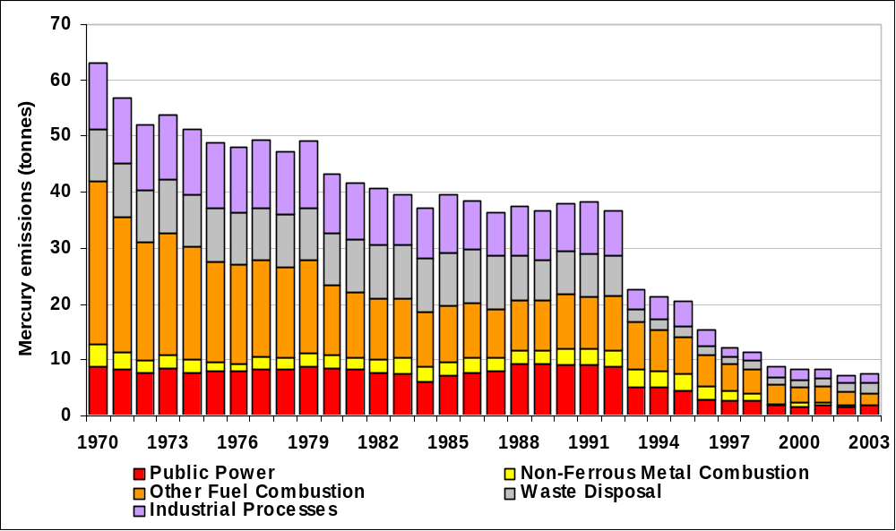

Speciation of Mercury Emissions
When mercury is emitted to air it occurs in one of several different forms, and the emissions of each of these forms has been estimated individually- the emissions have been “speciated”.

Three species of mercury have been considered:
 | Hg⁰ | unreactive gaseous elemental Hg
 | Hg-p | mercury attached to particulate material
 | RGM | reactive gaseous mercury (includes inorganic and organic forms normally in Hg²⁺ oxidised form)

The methodology for estimating the emissions of each of these three species is similar to that used for speciating the NMVOC emissions. Each source of mercury emission is considered individually. A speciation profile identifying the fractional contribution from each species to the mercury emission from that source is then applied. Summing across the individual sources then allows a total for each of the three species to be evaluated.

Table 6.18b Speciated Emissions of Mercury (tonnes)
 | Hg⁰ | Hg-p | RGM | Total (2003)
BY UN/ECE CATEGORY
Combustion in Energy Prod | 0.9 | 0.2 | 0.8 | 1.9
Combustion in Comm/Res | 0.1 | 0.1 | 0.1 | 0.3
Combustion in Industry | 1.1 | 0.1 | 0.5 | 1.7
Production Processes | 1.1 | 0.0 | 0.4 | 1.6
Road Transport | 0 | 0 | 0 | 0
Other Trans/Machinery | 0 | 0 | 0 | 0
Waste | 0.4 | 0.0 | 1.5 | 1.9
TOTAL | 3.7 | 0.4 | 3.3 | 7.4

The profiles used for the speciation are based on the recommendations given in Passant et al (2002a). In general, these profiles are subject to great uncertainty and further measurement data are required, particularly for major sources such as coal combustion, crematoria, clinical waste incinerators, sinter plant, chloralkali processes, and primary lead/zinc production.

Emissions of Nickel
Inhalation of nickel can cause irritation to the nose and sinuses and can also lead to the loss of the sense of smell. Long term exposure may lead to asthma or other respiratory diseases. Cancer of the lungs, nose and sinuses as well as the larynx and stomach has been attributed to exposure to nickel.

Table 6.19a and Figure 6.16 summarise the UK emissions of nickel. Emissions have declined by 85% since 1970. Currently the main sources of nickel emissions is the combustion of heavy fuel oil, however in the past coal combustion was a major source. Emissions from both sources have declined in use since 1970 in favour of natural gas and are largely responsible for the reduction in total emissions. Between 1989 and 1997, heavy fuel oil was replaced by Orimulsion (an emulsion of bitumen in water) in some power stations. The nickel content of Orimulsion was higher than that of heavy fuel oil and resulted in higher emissions in spite of the flue gas cleaning equipment required on these power stations. Emissions from refineries are important because of the large amount of refinery fuel oil and residues burnt.
Table 6.19a UK Emissions of Nickel by UN/ECE Category and Fuel (tonnes)
 | 1970 | 1980 | 1990 | 1996 | 1997 | 1998 | 1999 | 2000 | 2001 | 2002 | 2003 | 2003%
BY UN/ECE CATEGORY¹
Combustion in Energy Prod
Public Power | 144.4 | 96.3 | 96.5 | 53.8 | 17.6 | 16.1 | 11.2 | 12.3 | 10.5 | 6.4 | 5.1 | 3%
Petroleum Refining Plants | 139.5 | 138.2 | 98.5 | 111.0 | 113.3 | 116.6 | 102.9 | 86.6 | 93.3 | 104.7 | 101.3 | 56%
Other Combustion & Trans. | 2.0 | 0.7 | 0.1 | 0.0 | 0.0 | 0.0 | 0.0 | 0.0 | 0.0 | 0.0 | 0.0 | 0%
Comb in Comm/Res
Residential Plant | 19.8 | 9.3 | 4.6 | 3.3 | 3.0 | 2.9 | 3.0 | 2.5 | 2.9 | 2.6 | 2.2 | 1%
Comm/Agricul Combustion | 162.1 | 76.5 | 38.4 | 34.0 | 25.5 | 20.9 | 21.5 | 11.6 | 13.1 | 10.4 | 12.2 | 7%
Combustion in Industry
Iron & Steel Combustion | 170.6 | 45.9 | 13.8 | 7.6 | 6.3 | 4.2 | 2.9 | 2.9 | 4.1 | 3.2 | 1.7 | 1%
Non-Ferrous Metals | 1.2 | 0.9 | 0.8 | 0.9 | 1.0 | 0.6 | 2.4 | 0.4 | 0.4 | 0.6 | 0.3 | 0%
Other Ind. Combustion | 526.4 | 303.5 | 129.7 | 76.6 | 61.9 | 49.9 | 32.3 | 27.6 | 36.2 | 30.8 | 40.3 | 22%
Production Processes
Iron & Steel Combustion | 16.9 | 13.0 | 14.3 | 13.2 | 14.0 | 12.3 | 6.0 | 6.1 | 3.9 | 2.5 | 3.1 | 2%
Non-Ferrous Metals | 5.6 | 6.5 | 6.7 | 7.9 | 7.6 | 8.1 | 8.3 | 8.5 | 8.3 | 6.3 | 5.5 | 3%
Processes in Industry | 2.3 | 2.1 | 3.1 | 2.9 | 1.5 | 1.7 | 1.7 | 1.8 | 0.7 | 0.5 | 0.4 | 0%
Road Transport | 1.0 | 1.2 | 1.8 | 1.9 | 1.9 | 1.9 | 1.9 | 1.9 | 1.9 | 2.0 | 2.0 | 1%
Other Trans/Machinery | 18.2 | 9.0 | 8.7 | 11.0 | 9.5 | 8.5 | 7.1 | 6.1 | 5.0 | 4.7 | 5.4 | 3%
Waste | 0.5 | 0.5 | 0.4 | 0.4 | 0.1 | 0.2 | 0.2 | 0.2 | 0.3 | 0.2 | 0.2 | 0%
By FUEL TYPE
Solid | 59.9 | 47.4 | 39.9 | 20.6 | 15.1 | 18.0 | 12.9 | 12.7 | 10.7 | 7.3 | 5.8 | 3%
Petroleum | 1092.0 | 616.5 | 337.9 | 269.1 | 215.6 | 195.5 | 164.5 | 134.2 | 152.6 | 154.0 | 161.0 | 90%
Gas | 0.0 | 0.0 | 0.0 | 0.0 | 0.0 | 0.0 | 0.0 | 0.0 | 0.0 | 0.0 | 0.0 | 0%
Non-Fuel | 58.6 | 39.8 | 39.6 | 34.8 | 32.7 | 30.4 | 24.1 | 21.6 | 17.4 | 13.7 | 13.0 | 7%
TOTAL | 1210.5 | 703.7 | 417.4 | 324.5 | 263.3 | 243.9 | 201.4 | 168.5 | 180.7 | 175.0 | 179.7 | 100%
¹ See Annex 1 for definition of UN/ECE Categories

Figure 6.16 Time Series of Nickel Emissions (tonnes)
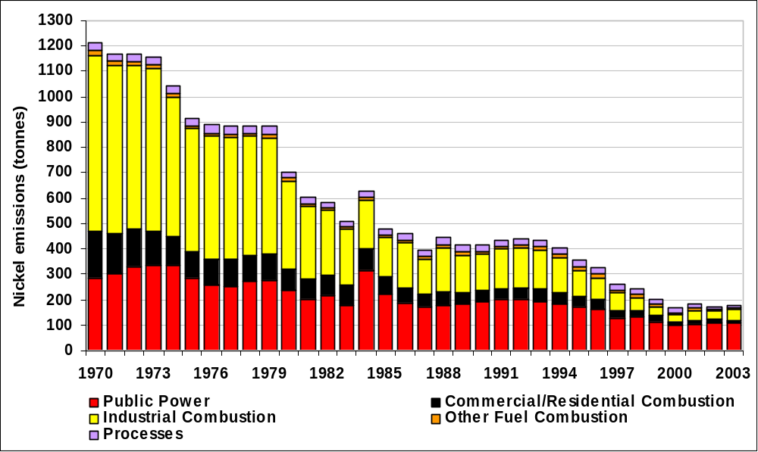

Speciation of Nickel Emissions

Nickel is emitted to air in a many different forms, which have been grouped into five 'species' for the NAEI:

- MN metallic nickel
- ON oxidic nickel compounds such as NiO and Ni₂O₃
- SolN soluble nickel salts such as nickel sulphates and nickel chlorides
- NC nickel carbonyl, Ni(CO)₄
- SU sulphidic nickel compounds e.g. nickel sulphide (NiS) & nickel subsulphide (Ni₃S₂)

The proportion of each form emitted by each source has been estimated and the overall split between the two forms is shown in Table 6.19b

Table 6.19b Speciated Emissions of Nickel 2003 (tonnes)
 | MN | ON | SolN | NC | SU | Total (2003)
BY UN/ECE CATEGORY
Combustion in Energy Prod | 0.0 | 41.5 | 61.1 | 0.6 | 3.3 | 106.4
Combustion in Comm/Res | 0.0 | 5.6 | 8.3 | 0.1 | 0.4 | 14.4
Combustion in Industry | 0.5 | 17.9 | 22.6 | 0.2 | 1.1 | 42.3
Production Processes | 2.8 | 6.0 | 0.3 | 0.1 | 0.0 | 9
Road Transport | 0.0 | 0.7 | 1.0 | 0.0 | 0.0 | 2
Other Trans/Machinery | 0.0 | 2.0 | 3.0 | 0.0 | 0.3 | 5.4
Waste | 0.0 | 0.1 | 0.1 | 0.0 | 0.0 | 0.2
TOTAL | 3.2 | 73.8 | 96.4 | 0.9 | 5.2 | 179.7

The profiles used for the speciation are based on the recommendations given in Passant et al (2002a). In general, these profiles are subject to great uncertainty and better data are desirable, particularly for major sources such as combustion of coal, fuel oil, anthracite, and petroleum coke, and electric arc furnaces. However current measurement techniques are not able to provide much useful data and so significant improvements are not likely in the short term.

Emissions of Selenium
Acute exposure to selenium by inhalation results in respiratory effects such as irritation to the mucous membranes, severe bronchitis and bronchial pneumonia.

Table 6.20 and Figure 6.17 summarise the UK emissions of selenium. Emissions have declined by 60% since 1970. The main source of selenium emissions is coal combustion in early years. Only trace amounts are emitted by the combustion of petroleum based fuels. Glass production has previously been considered the dominant source. The estimates for the manufacture of the various types of glass products (flat glass, container glass etc.) are uncertain and there are on-going improvements to the emission estimates. Revised estimates have been made for flat glass and this has significantly reduced the national estimate of selenium emissions.

Table 6.20 UK Emissions of Selenium by UN/ECE Category and Fuel (tonnes)
 | 1970 | 1980 | 1990 | 1996 | 1997 | 1998 | 1999 | 2000 | 2001 | 2002 | 2003 | 2003%
BY UN/ECE CATEGORY¹
Combustion in Energy Prod
Public Power | 53.0 | 59.9 | 55.4 | 26.5 | 17.6 | 22.0 | 11.5 | 14.4 | 13.9 | 11.3 | 11.5 | 27%
Petroleum Refining Plants | 1.5 | 1.5 | 0.8 | 0.9 | 0.9 | 0.9 | 0.8 | 0.6 | 0.7 | 0.8 | 0.9 | 2%
Other Combustion & Trans. | 0.9 | 0.3 | 0.1 | 0.0 | 0.0 | 0.0 | 0.0 | 0.0 | 0.0 | 0.0 | 0.0 | 0%
Combustion in Comm/Res
Residential Plant | 11.7 | 5.6 | 3.0 | 2.4 | 2.2 | 2.2 | 2.1 | 1.9 | 2.1 | 1.9 | 1.4 | 3%
Comm/Agricul Combustion | 5.6 | 2.9 | 1.7 | 1.2 | 1.1 | 0.9 | 0.8 | 0.6 | 0.6 | 0.5 | 0.4 | 1%
Combustion in Industry
Iron & Steel Combustion | 5.4 | 1.8 | 2.5 | 2.4 | 2.5 | 2.4 | 2.2 | 2.0 | 1.9 | 1.6 | 1.9 | 4%
Non-Ferrous Metals | 0.0 | 0.0 | 0.0 | 0.0 | 0.0 | 0.0 | 0.0 | 0.0 | 0.0 | 0.0 | 0.0 | 0%
Other Ind. Combustion | 8.3 | 5.1 | 3.0 | 2.4 | 2.3 | 2.2 | 1.9 | 1.8 | 2.2 | 1.9 | 3.8 | 9%
Production Processes
Iron & Steel Combustion | 0.3 | 0.1 | 0.2 | 0.2 | 0.2 | 0.2 | 0.2 | 0.2 | 0.2 | 0.1 | 0.2 | 0%
Non-Ferrous Metals | 0.0 | 0.0 | 0.0 | 0.0 | 0.0 | 0.0 | 0.0 | 0.0 | 0.0 | 0.0 | 0.0 | 0%
Processes in Industry | 11.6 | 13.7 | 12.4 | 13.4 | 13.6 | 12.9 | 11.7 | 11.9 | 12.0 | 11.2 | 11.3 | 27%
Road Transport | 5.1 | 6.6 | 9.3 | 9.7 | 9.9 | 9.8 | 9.9 | 9.8 | 9.8 | 10.0 | 10.0 | 24%
Other Trans/Machinery | 1.2 | 1.1 | 1.2 | 1.1 | 1.0 | 1.0 | 0.9 | 0.9 | 0.8 | 0.8 | 0.8 | 2%
By FUEL TYPE
Solid | 66 | 65 | 58 | 28 | 20 | 24 | 13 | 16 | 15 | 12 | 14 | 33%
Petroleum | 22 | 18 | 16 | 15 | 15 | 15 | 14 | 14 | 14 | 14 | 14 | 34%
Gas | 0 | 0 | 0 | 0 | 0 | 0 | 0 | 0 | 0 | 0 | 0 | 0%
Non-Fuel | 16 | 16 | 15 | 17 | 17 | 16 | 14 | 14 | 14 | 13 | 14 | 33%
TOTAL | 104.7 | 98.7 | 89.4 | 60.3 | 51.3 | 54.5 | 42.1 | 44.2 | 44.4 | 40.1 | 42.2 | 100%
¹ See Annex 1 for definition of UN/ECE Categories

Figure 6.17 Time Series of Selenium Emissions (tonnes)
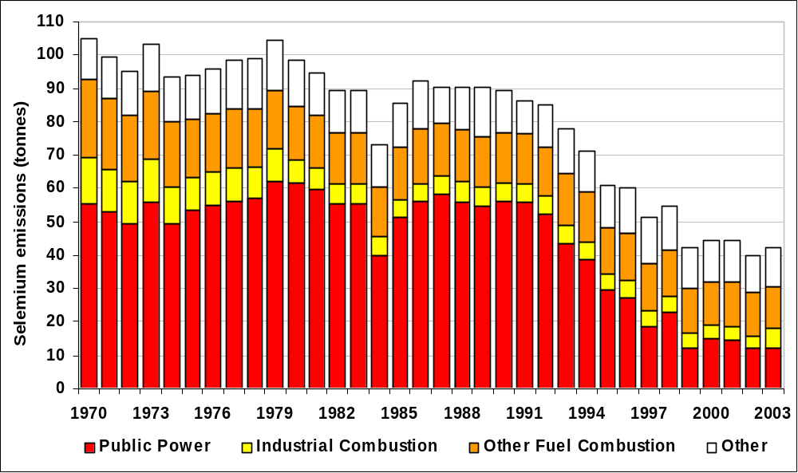

Emissions of Vanadium
Acute exposure to vanadium by inhalation can cause irritation to the respiratory tract. Chronic exposure may lead to pneumonia.

Table 6.21 and Figure 6.18 summarise the UK emissions of vanadium. Emission data are rather scarce so the estimates are very uncertain. Estimates of emissions have declined by 73% since 1970. The major source of emissions are the road transport sector accounting for 41% and the combustion of fuel oils with liquid fuels accounting for some 32% of the estimated emission in 2003. The total contribution from petroleum based fuels is 99% of the total vanadium emission. The reduction in emissions with time reflects the decline in the use of fuel oils by the electricity supply industry, industry in general and the domestic sector. Between 1989 and 1997, heavy fuel oil was partly replaced by Orimulsion (an emulsion of bitumen in water) in some power stations. Emissions from refineries are very important because of the high consumption of heavy fuel oil and residues. The vanadium content of Orimulsion was higher than that of heavy fuel oil and resulted in higher emissions in spite of the flue gas cleaning equipment required on these power stations. Of the other sources, estimates for the iron and steel industry are very uncertain since emissions will depend on the type of steel or alloy produced and its vanadium content. The available emissions data apply only to a generalised steel production process.

Table 6.21 UK Emissions of Vanadium by UN/ECE Category and Fuel (tonnes)
 | 1970 | 1980 | 1990 | 1996 | 1997 | 1998 | 1999 | 2000 | 2001 | 2002 | 2003 | 2003%
BY UN/ECE CATEGORY¹
Combustion in Energy Prod
Public Power | 502 | 288 | 298 | 180 | 40 | 20 | 15 | 20 | 22 | 9 | 10 | 1%
Petroleum Refining Plants | 570 | 562 | 398 | 450 | 459 | 472 | 417 | 350 | 378 | 423 | 412 | 32%
Other Combustion & Trans. | 1 | 0 | 0 | 0 | 0 | 0 | 0 | 0 | 0 | 0 | 0 | 0%
Combustion in Comm/Res
Residential Plant | 47 | 26 | 12 | 8 | 7 | 6 | 6 | 5 | 7 | 7 | 6 | 0%
Comm/Agricul Combustion | 684 | 379 | 200 | 179 | 140 | 120 | 119 | 77 | 79 | 64 | 62 | 5%
Combustion in Industry
Iron & Steel Combustion | 583 | 135 | 15 | 9 | 9 | 5 | 4 | 8 | 16 | 9 | 2 | 0%
Other Ind. Combustion | 2126 | 1248 | 528 | 319 | 262 | 217 | 146 | 128 | 174 | 153 | 210 | 16%
Production Processes
Iron & Steel Combustion | 8 | 4 | 6 | 6 | 7 | 6 | 5 | 5 | 5 | 4 | 5 | 0%
Processes in Industry | 0 | 0 | 0 | 0 | 0 | 0 | 0 | 0 | 0 | 0 | 0 | 0%
Road Transport | 149 | 173 | 316 | 426 | 444 | 449 | 460 | 464 | 476 | 502 | 525 | 41%
Other Trans/Machinery | 59 | 57 | 58 | 66 | 58 | 53 | 47 | 43 | 36 | 31 | 45 | 4%
By FUEL TYPE
Solid | 50 | 44 | 39 | 19 | 13 | 15 | 12 | 14 | 13 | 6 | 7 | 1%
Petroleum | 4719 | 2844 | 1801 | 1629 | 1417 | 1336 | 1211 | 1091 | 1183 | 1201 | 1272 | 99%
Gas | 0 | 0 | 0 | 0 | 0 | 0 | 0 | 0 | 0 | 0 | 0 | 0%
Non-Fuel | 13 | 8 | 10 | 10 | 10 | 10 | 9 | 7 | 7 | 6 | 6 | 0%
TOTAL | 4782 | 2895 | 1850 | 1659 | 1441 | 1361 | 1231 | 1111 | 1203 | 1212 | 1285 | 100%
¹ See Annex 1 for definition of UN/ECE Categories

Figure 6.18 Time series of Vanadium Emissions (tonnes)
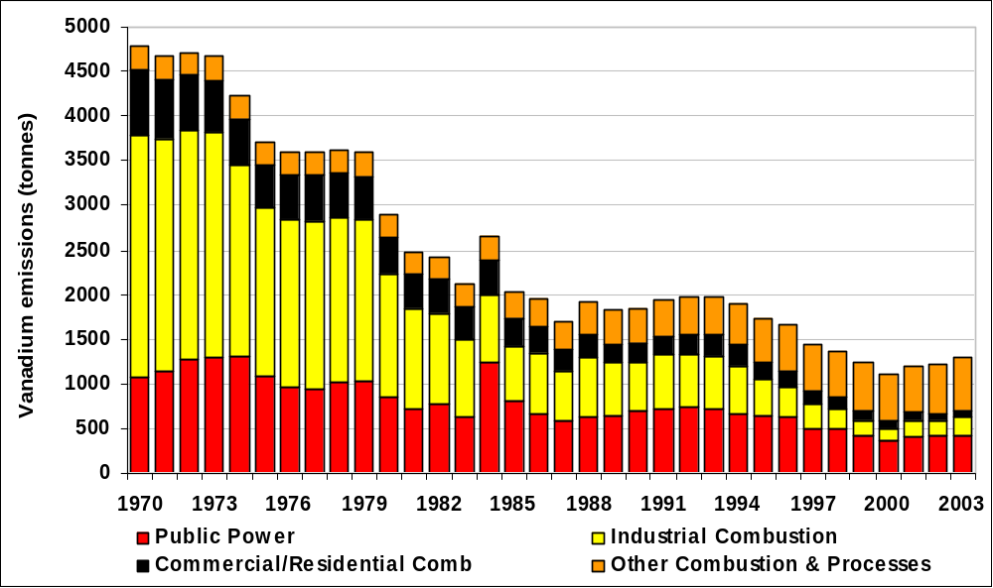

Emissions of Zinc
Although zinc metal poses no documented health risks, if its physical state is altered during use then health risks can be created. Inhalation of metallic oxide fumes can lead to metal fume fever.

Table 6.22 and Figure 6.19 summarise the UK emissions of zinc. Emissions of zinc have declined by 68% since 1970. The main sources are iron and steel production and combustion in industry. The road transport emission is almost entirely due to tyre wear. This arises from the zinc content of the tyre rubber - around 2% ZnO by weight. The reduction in emissions over the period considered is largely due to the decline in coal combustion and improvements in abatement measures in the iron and steel industry. The large reduction in emissions from MSW incinerators is due to improved emission controls applied from 1997 onwards.

Table 6.22 UK Emissions of Zinc by UN/ECE Category and Fuel (tonnes)
 | 1970 |  | 1980 | 1990 | 1996 | 1997 | 1998 | 1999 | 2000 | 2001 | 2002 | 2003 | 2003%
BY UN/ECE CATEGORY¹
Combustion in Energy Prod
Public Power | 31 | 32 |  | 30 | 31 | 28 | 27 | 19 | 12 | 10 | 9 | 11 | 2%
Petroleum Refining Plants | 5 | 5 |  | 4 | 4 | 4 | 4 | 4 | 3 | 4 | 4 | 4 | 1%
Other Combustion & Trans. | 11 | 4 |  | 1 | 0 | 0 | 0 | 0 | 0 | 0 | 0 | 0 | 0%
Combustion in Comm/Res
Residential Plant | 65 | 30 |  | 15 | 10 | 9 | 9 | 9 | 8 | 8 | 7 | 5 | 1%
Comm/Agricul Combustion | 45 |  | 17 | 10 | 5 | 5 | 4 | 3 | 2 | 2 | 1 | 1 | 0%
Combustion in Industry
Iron & Steel Combustion | 310 |  | 149 | 121 | 66 | 53 | 40 | 27 | 18 | 17 | 15 | 16 | 3%
Non-Ferrous Metals | 233 |  | 175 | 161 | 154 | 152 | 128 | 114 | 119 | 88 | 92 | 27 | 6%
Other Ind. Combustion | 363 |  | 255 | 230 | 254 | 258 | 227 | 206 | 207 | 218 | 212 | 221 | 45%
Production Processes
Iron & Steel | 383 |  | 280 | 337 | 319 | 335 | 300 | 195 | 158 | 157 | 120 | 112 | 23%
Non-Ferrous Metals | 0 |  | 0 | 0 | 0 | 0 | 0 | 0 | 0 | 0 | 1 | 1 | 0%
Processes in Industry | 31 |  | 34 | 18 | 10 | 8 | 9 | 9 | 11 | 7 | 7 | 3 | 1%
Road Transport
Combustion | 0 |  | 1 | 1 | 1 | 1 | 1 | 1 | 1 | 1 | 1 | 1 | 0%
Brake & Tyre Wear | 39 |  | 51 | 73 | 79 | 81 | 82 | 84 | 84 | 85 | 88 | 89 | 18%
Other Trans/Machinery | 1 |  | 1 | 1 | 1 | 1 | 1 | 1 | 1 | 1 | 0 | 1 | 0%
Waste | 10 |  | 10 | 9 | 9 | 5 | 2 | 2 | 4 | 2 | 2 | 2 | 0%
By FUEL TYPE
Solid | 180 |  | 90 | 62 | 36 | 30 | 31 | 27 | 25 | 26 | 21 | 20 | 4%
Petroleum | 45 |  | 27 | 16 | 12 | 10 | 9 | 8 | 8 | 8 | 9 | 9 | 2%
Gas
Non-Fuel | 1,304 |  | 926 | 934 | 896 | 901 | 792 | 639 | 595 | 566 | 529 | 463 | 94%
TOTAL | 1529 |  | 1043 | 1011 | 944 | 941 | 832 | 675 | 627 | 600 | 559 | 492 | 100%
¹ See Annex 1 for definition of UN/ECE Categories

Figure 6.19 Times Series of Zinc Emissions (tonnes)
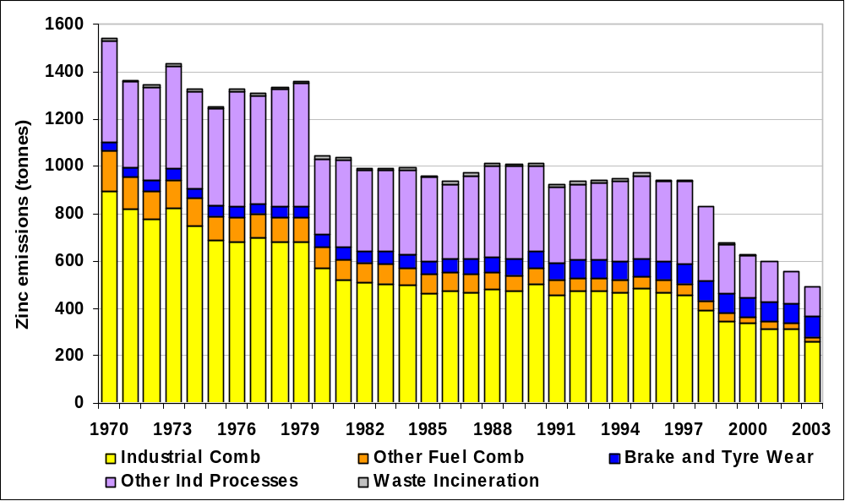

Emissions of Beryllium
Acute inhalation exposure to high levels of beryllium can lead to inflammation of the lungs. Long-term exposure can cause chronic beryllium disease where non-cancerous lesions form in the lungs. Studies also suggest that inhalation can lead to an increased risk of lung cancer.

Table 6.23 summarises the UK emissions of beryllium. Estimates have only been included since the 2000 NAEI report; therefore the figures are very uncertain. Emission factors have been calculated for the combustion of coal and heavy liquid fuels, but emission factors are not available for industrial processes, with the exception of iron & steel manufacture and a few other processes, where emission estimates have been based on data given in the Pollution Inventory. There is on-going development of the beryllium inventory, and improved data will be included in future versions of the NAEI.

Table 6.23 UK Emissions of Beryllium by UN/ECE Category and Fuel (tonnes)
 | 2000 | 2001 | 2002 | 2003 | 2003%
BY UN/ECE CATEGORY¹
Combustion in Energy Prod
Public Power | 0.4 | 0.4 | 0.2 | 0.2 | 0%
Petroleum Refining Plants | 0.5 | 0.7 | 0.8 | 0.8 | 0%
Other Combustion & Trans. | 0.0 | 0.0 | 0.0 | 0.0 | 0%
Combustion in Comm/Res
Residential Plant | 2.6 | 3.2 | 2.4 | 1.3 | 1%
Comm/Agricul Combustion | 0.7 | 0.6 | 0.5 | 0.4 | 0%
Combustion in Industry | 0.7 | 1.0 | 0.9 | 1.2 | 1%
Production Processes | 0.2 | 0.2 | 0.2 | 0.2 | 0%
Road Transport | 156.2 | 160.5 | 169.2 | 177.0 | 98%
Other Trans/Machinery | 0.4 | 0.4 | 0.3 | 0.4 | 0%
Waste | 0.0 | 0.0 | 0.0 | 0.0 | 0%
By FUEL TYPE
Solid | 3 | 4 | 3 | 2 | 1%
Petroleum | 159 | 163 | 172 | 180 | 99%
Gas | 0 | 0 | 0 | 0 | 0%
Non-Fuel | 0 | 0 | 0 | 0 | 0%
TOTAL | 162 | 167 | 175 | 181 | 100%
¹ See Annex 1 for definition of UN/ECE Categories

Emissions of Manganese
Long-term exposure to high levels of manganese can result in effects on the central nervous system such as visual reaction time, hand-eye coordination and hand steadiness. Exposure to higher levels over a long period of time can result in a syndrome known as manganism. This leads to feelings of weakness and lethargy, tremors and psychological disturbances.

Table 6.24 summarises the UK emissions of manganese. As estimates have only been included since the 2000 NAEI report the figures remain very uncertain. Emission factors have been calculated for the combustion of coal and heavy liquid fuels, but emission factors are not available for many industrial processes, with the exception of iron & steel manufacture and a few other processes, where emission estimates have been based on data given in the Pollution Inventory. Further development of the manganese inventory will occur in future versions of the NAEI.

Table 6.24 UK Emissions of Manganese by UN/ECE Category and Fuel (tonnes)
 | 2000 | 2001 | 2002 | 2003 | 2003%
BY UN/ECE CATEGORY¹
Combustion in Energy Prod
Public Power | 22 | 20 | 10 | 8 | 22%
Other Combustion & Trans. | 0 | 0 | 0 | 0 | 0%
Combustion in Comm/Res
Residential Plant | 2 | 3 | 2 | 1 | 4%
Comm/Agricul Combustion | 0 | 0 | 0 | 0 | 0%
Combustion in Industry | 12 | 11 | 12 | 11 | 30%
Production Processes | 29 | 21 | 15 | 16 | 42%
Waste | 0 | 0 | 0 | 0 | 1%
By FUEL TYPE
Solid | 33 | 31 | 20 | 18 | 47%
Petroleum | 0 | 0 | 0 | 0 | 0%
Gas | 0 | 0 | 0 | 0 | 0%
Non-Fuel | 32 | 24 | 20 | 20 | 53%
TOTAL | 66 | 55 | 40 | 38 | 100%
¹ See Annex 1 for definition of UN/ECE Categories

Emissions of Tin
Inhalation of dust and fumes may cause a disease of the lungs called stannosis. Table 6.25 summarises the UK emissions of tin. As estimates have only been included since the 2000 NAEI report the figures remain very uncertain. Emission factors have been calculated for the combustion of coal and heavy liquid fuels, but no data are available for other potential sources such as industrial processes. Further development of the tin inventory has been planned for future versions of the NAEI.

Table 6.25 UK Emissions of Tin by UN/ECE Category and Fuel (tonnes)
 | 2000 | 2001 | 2002 | 2003 | 2003%
BY UN/ECE CATEGORY¹
Combustion in Energy Prod
Public Power | 3.0 | 3.3 | 3.1 | 3.4 | 59%
Petroleum Refining Plants | 0.2 | 0.3 | 0.3 | 0.3 | 6%
Other Combustion & Trans. | 0.0 | 0.0 | 0.0 | 0.0 | 0%
Combustion in Comm/Res
Residential Plant | 0.4 | 0.4 | 0.4 | 0.2 | 4%
Comm/Agricul Combustion | 0.2 | 0.1 | 0.1 | 0.1 | 2%
Combustion in Industry | 3.3 | 3.3 | 0.9 | 1.0 | 17%
Production Processes | 0.6 | 0.5 | 0.4 | 0.4 | 7%
Road Transport | 0.2 | 0.2 | 0.2 | 0.2 | 3%
Other Trans/Machinery | 0.1 | 0.1 | 0.0 | 0.1 | 1%
Waste | 0.1 | 0.1 | 0.1 | 0.1 | 2%
By FUEL TYPE
Solid | 4.1 | 4.4 | 4.0 | 4.2 | 72%
Petroleum | 0.8 | 1.0 | 1.0 | 1.0 | 18%
Gas | 0.0 | 0.0 | 0.0 | 0.0 | 0%
Non-Fuel | 3.0 | 2.8 | 0.6 | 0.6 | 10%
TOTAL | 7.9 | 8.3 | 5.5 | 5.8 | 100%
¹ See Annex 1 for definition of UN/ECE Categories

Spatial Disaggregation of Heavy Metals
All of the heavy metal emission estimates presented here have been spatially disaggregated with the exception of beryllium, manganese and tin, and UK maps are presented in Figures 6.20 to 6.29. The key features that are evident from the maps are briefly considered here:

Arsenic
Significant emissions arise from coal combustion, and consequently emissions in Northern Ireland are noted to be relatively high. Individual points sources are also evident.

Cadmium
The major source for 2003 arises from activities associated with non-ferrous metals, but the emissions from this source are not readily visible in a map, so road transport emissions appear the dominant source.

Chromium and Copper
The dominant sources of chromium are coal combustion, iron and steel production processes, and chromium-based chemicals manufacture. In the case of copper, the main sources are coal combustion, iron and steel manufacture and non-ferrous metals production. From the UK emission maps it can be seen that there are a number of point sources, and elevated emissions in Northern Ireland for both of these pollutants.

Lead
A significant contribution of the lead emissions comes from the non-ferrous metal industry but these point sources are not readily visible on the UK emissions map. Selected motorways are clearly visible from the UK emission map.

Mercury
The major sources of mercury in 2003 were waste incineration, coal combustion and specific industrial activities. As a result the UK emission map highlights a number of point sources. Other emissions are generally located in urban areas.

Nickel
Emissions of nickel are dominated by the combustion of coal and heavy fuel oil. Consequently areas of the country with refinery activities are highlighted. It is also interesting to note that urban areas are not particularly elevated, This is due to the higher use of gas in the domestic sector in areas of higher population density.

Selenium
Emissions of selenium arise from power generation and selected industrial processes as well as road transport. Consequently the UK emissions map displays major point sources, which can eb rather difficult to see, as well as highlighting the road network.

Vanadium
Vanadium emissions primarily arise from refineries, road transport an the combustion of heavy fuel oil. As a result a large number of point sources may be identified from the emissions map, and the major road network is highlighted. Areas with low population density and domestic coal use are particularly highlighted as having low emissions.

Zinc
Zinc emissions primarily arise from combustion in the non-ferrous metals sector, iron and steel production processes and road transport (brake and tyre wear). As a result the UK emissions map highlights the road network and a number of point sources. However, the point sources are difficult to see due to the large number of grid cells where emissions are governed by the road transport sector.
Figure 6.20 UK Emissions Map of Arsenic 2003 | Figure 6.21 UK Emissions Map of Cadmium 2003
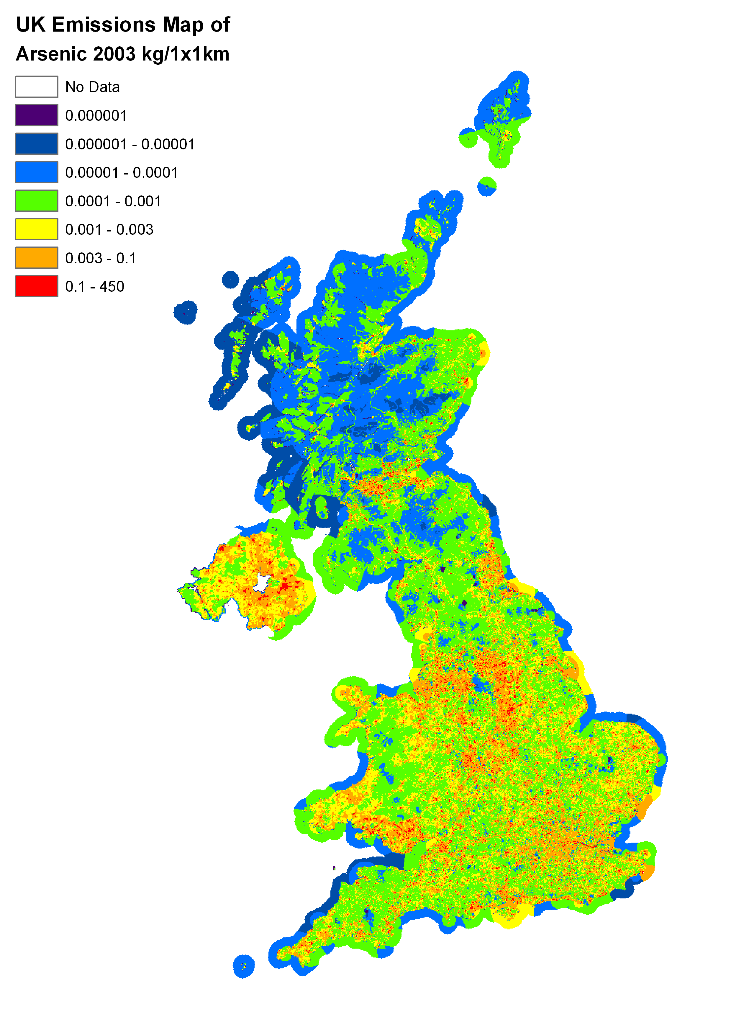 | 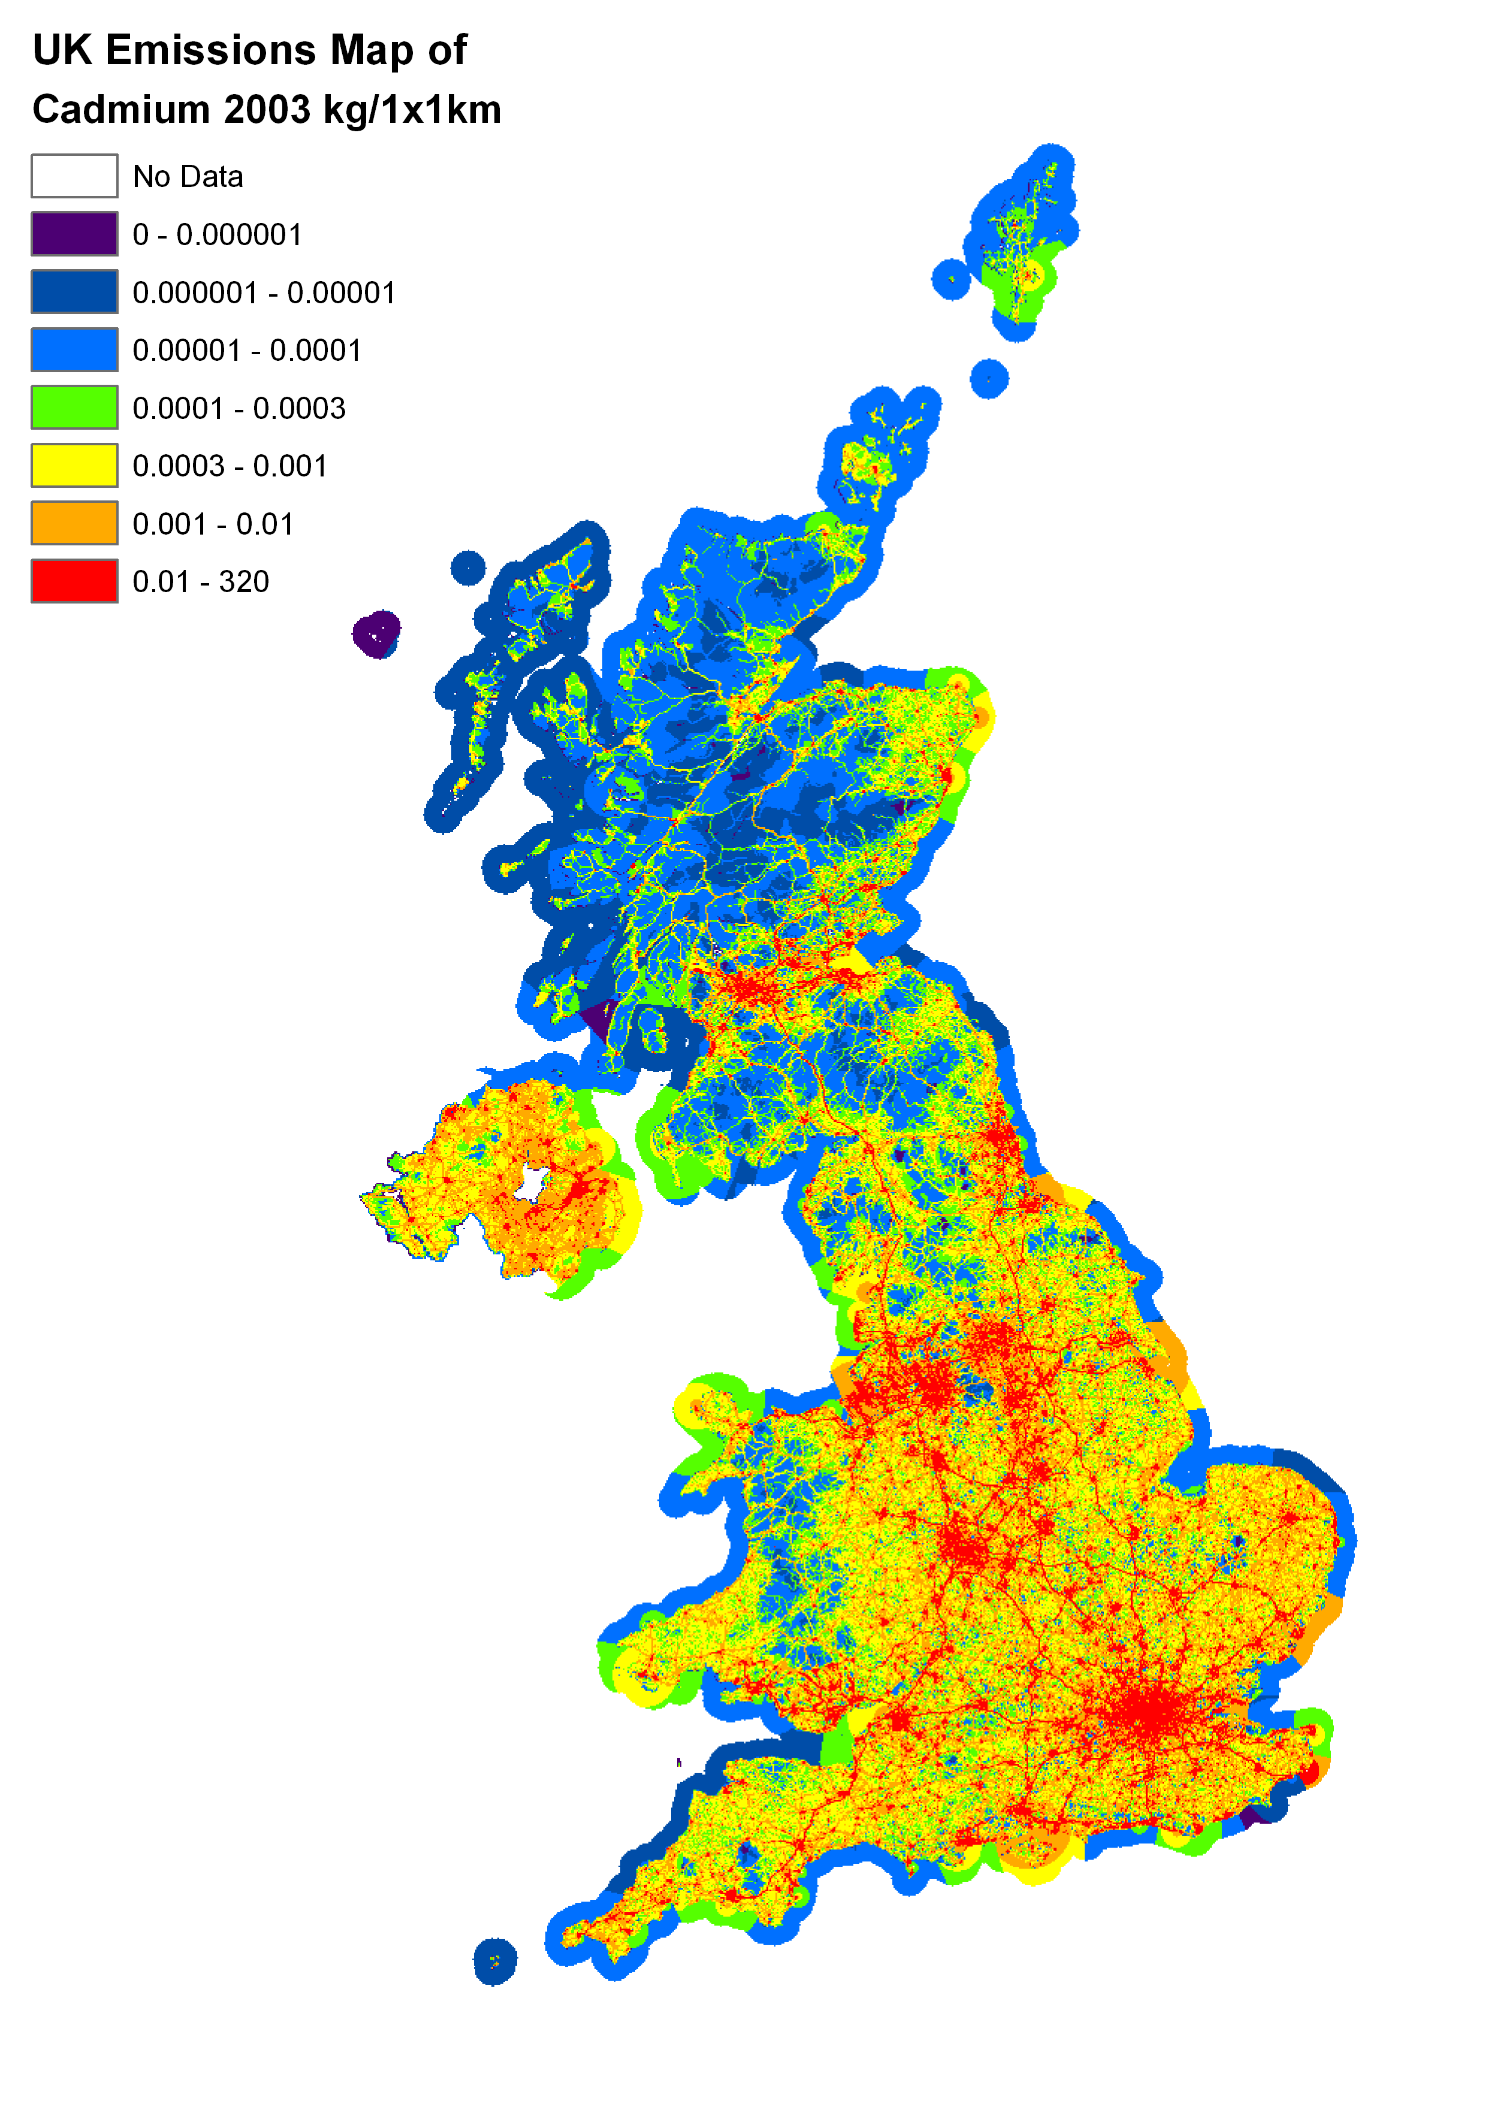
Figure 6.22 UK Emissions Map of Chromium 2003 | Figure 6.23 UK Emissions Map of Copper 2003
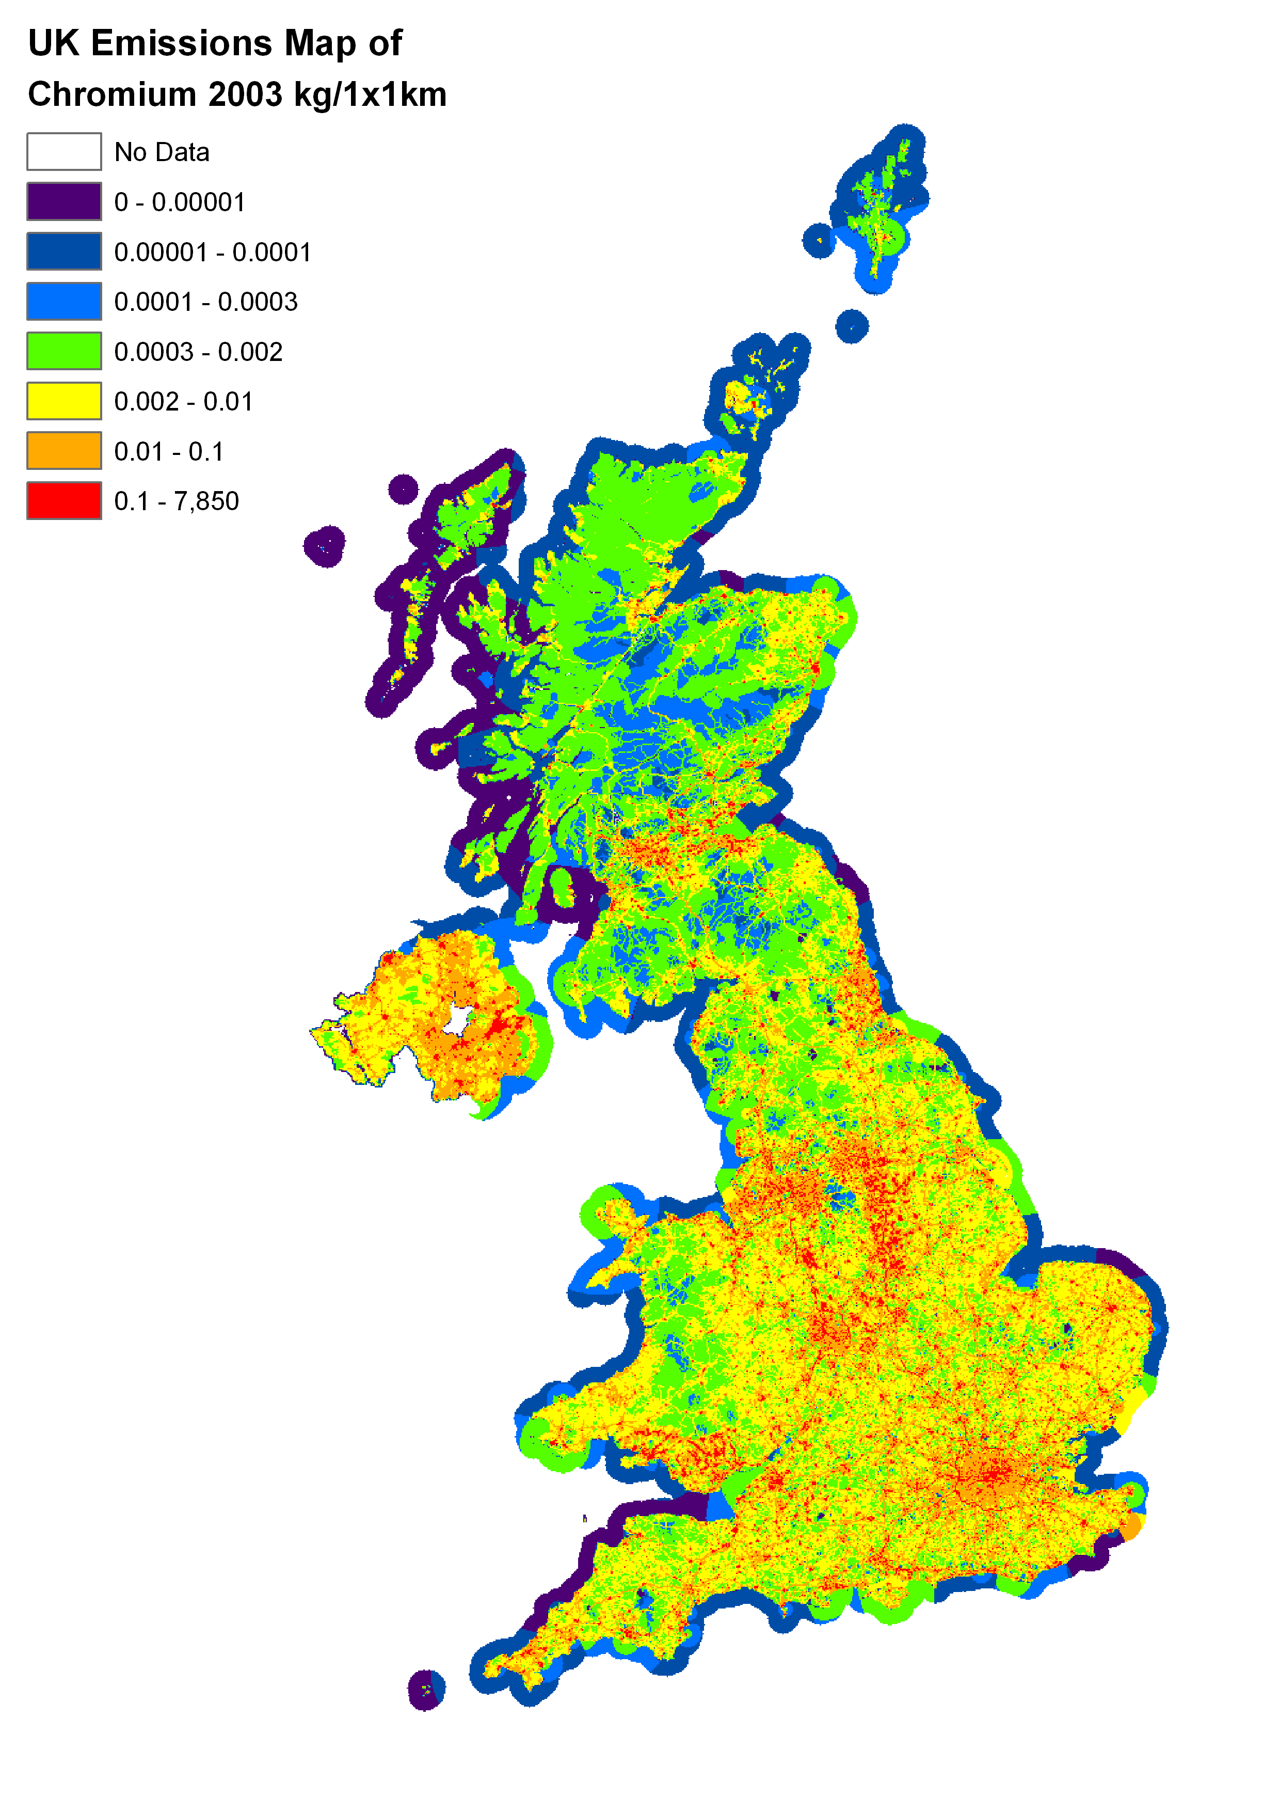 | 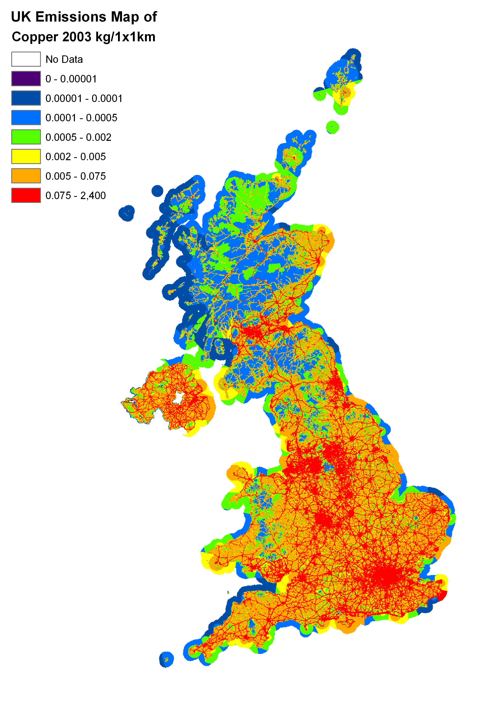

Figure 6.24 UK Emissions Map of Lead 2003 | Figure 6.25 UK Emissions Map of Mercury 2003
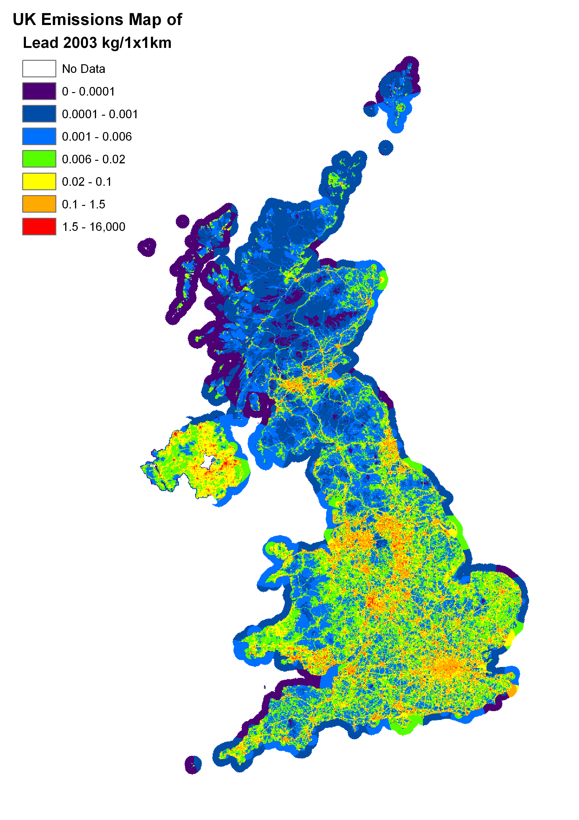 | 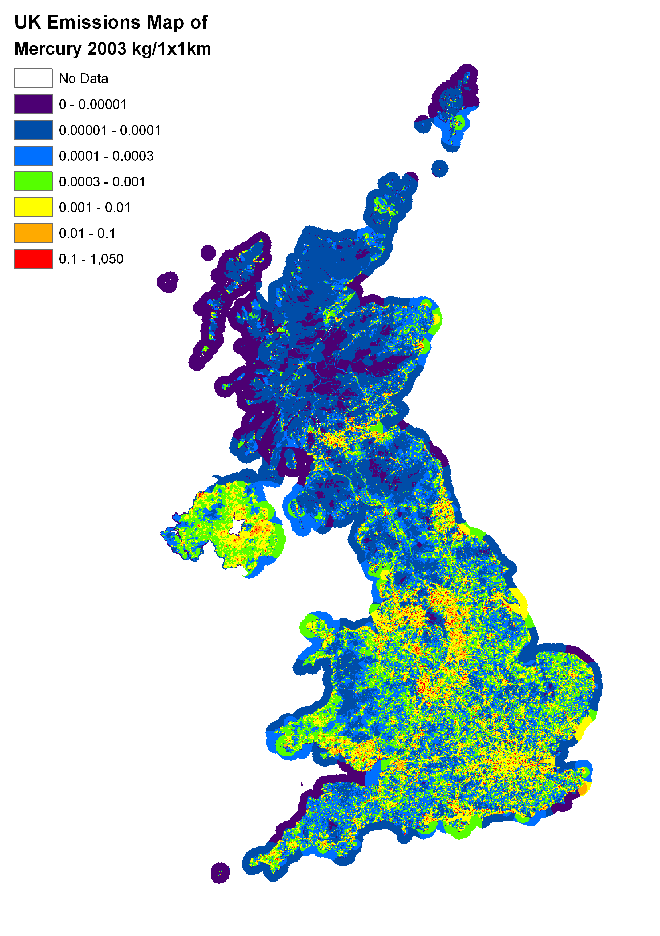
Figure 6.26 UK Emissions Map of Nickel 2003 | Figure 6.27 UK Emissions Map of Selenium 2003
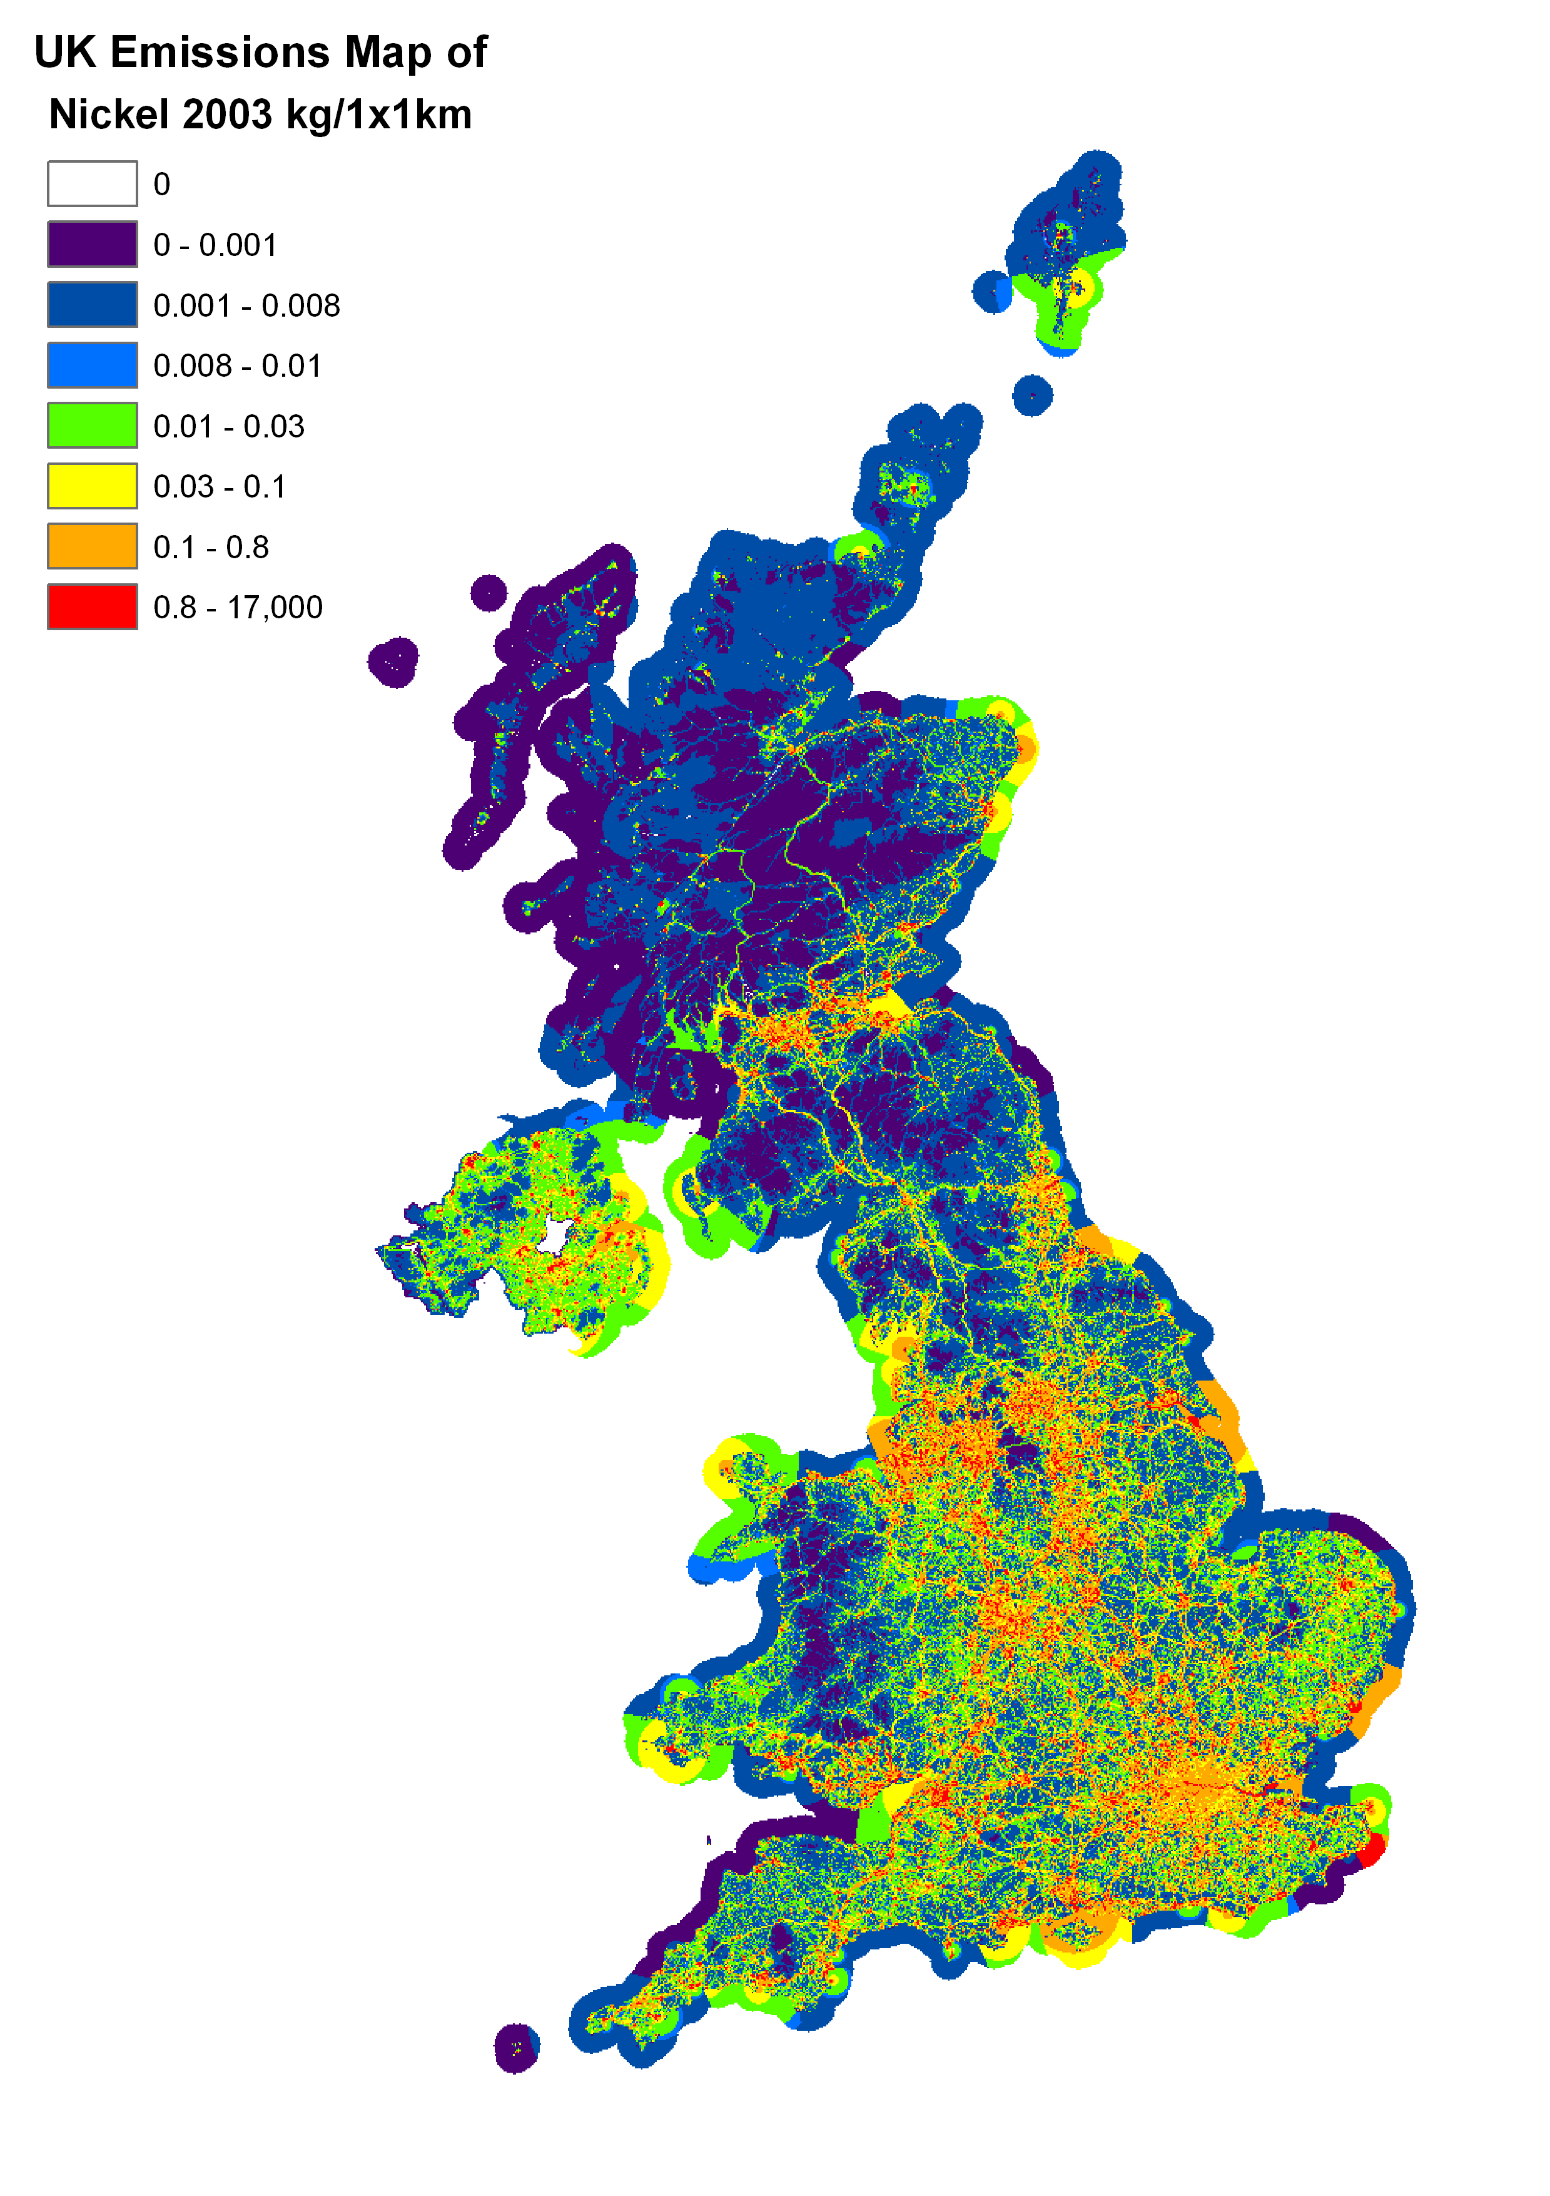 | 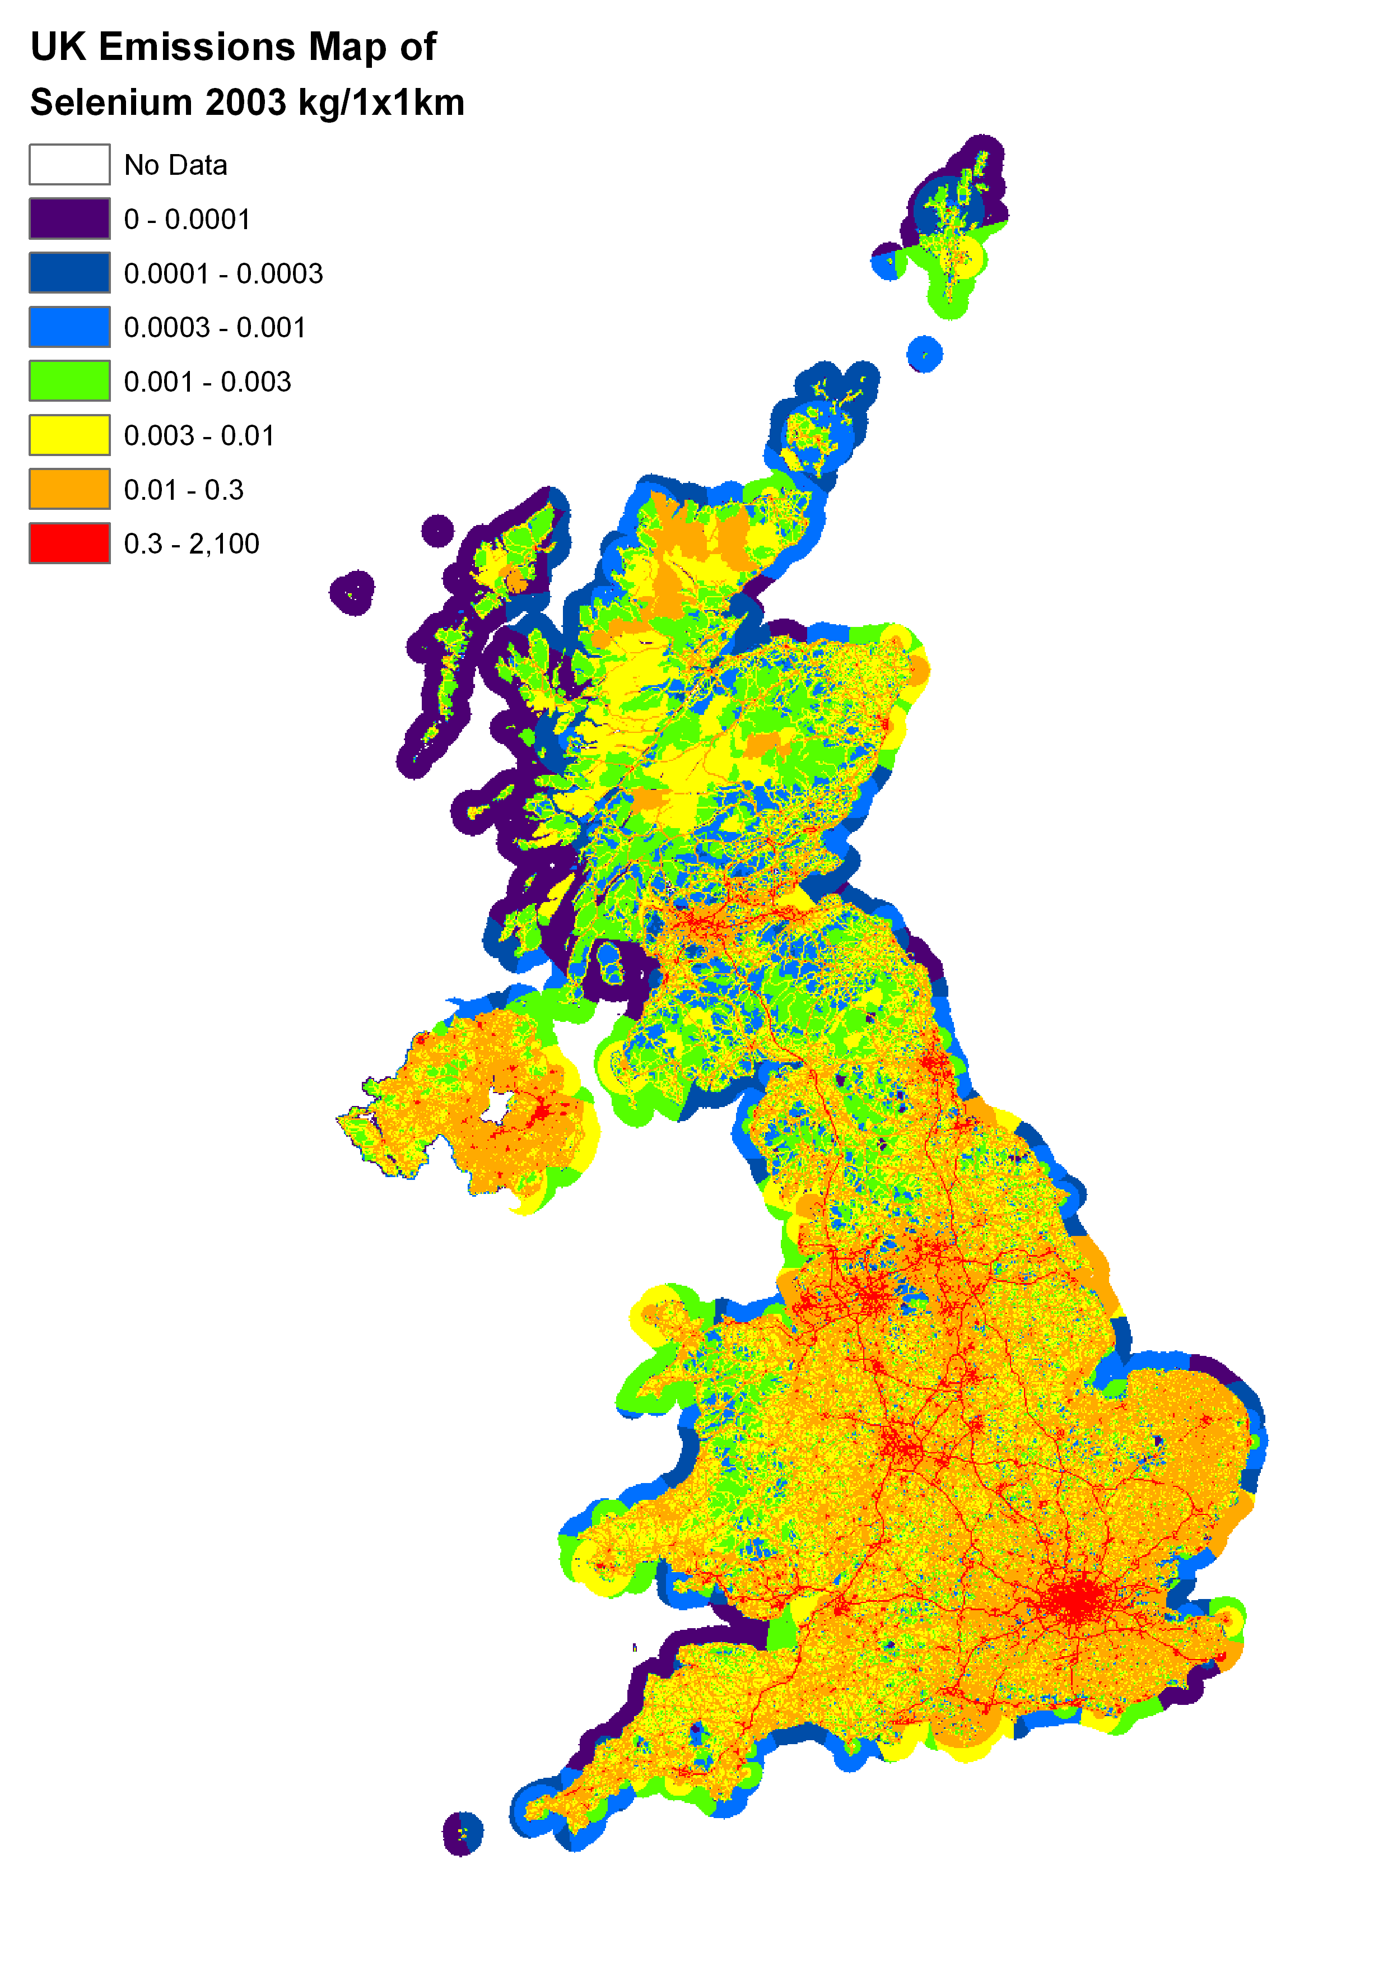

Figure 6.28 UK Emissions Map of Vanadium 2003 | Figure 6.29 UK Emissions Map of Zinc 2003
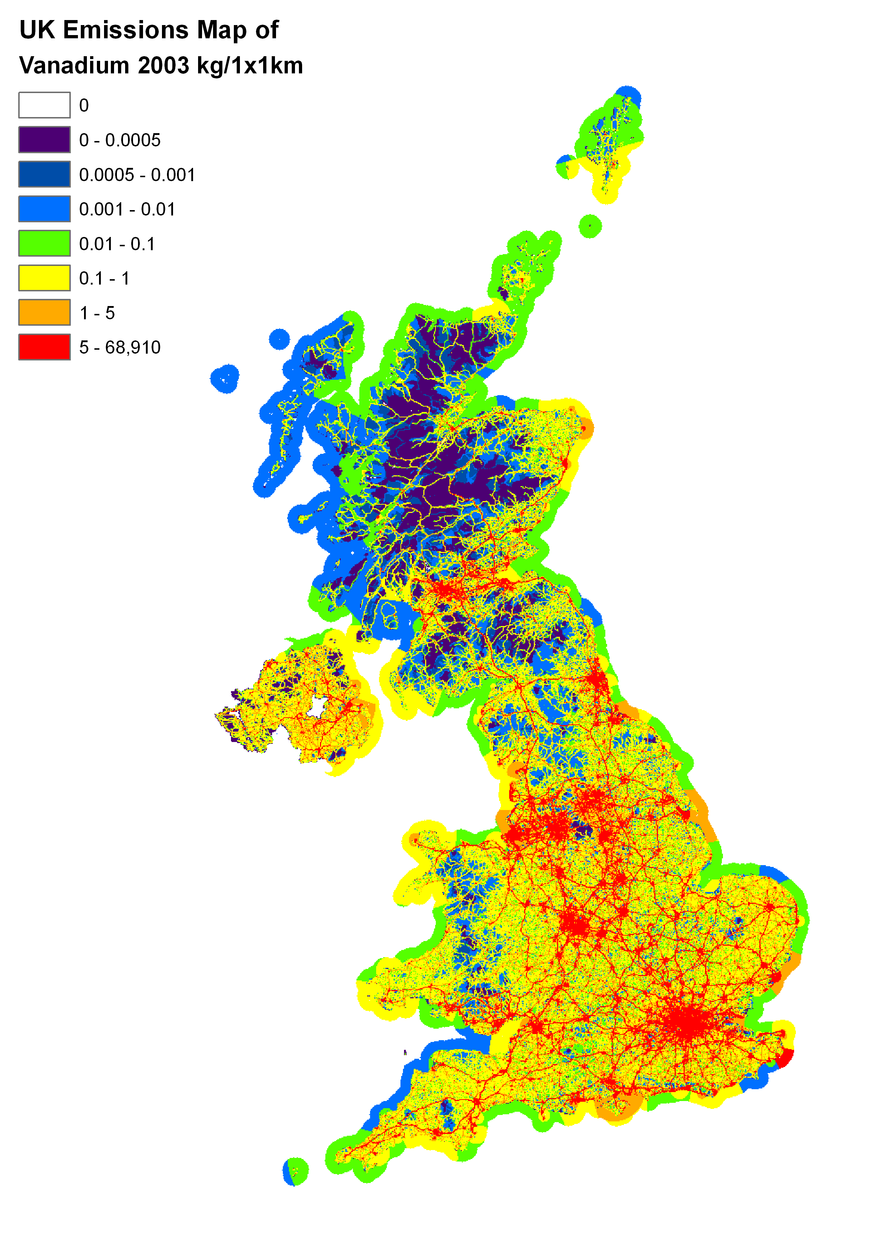 | 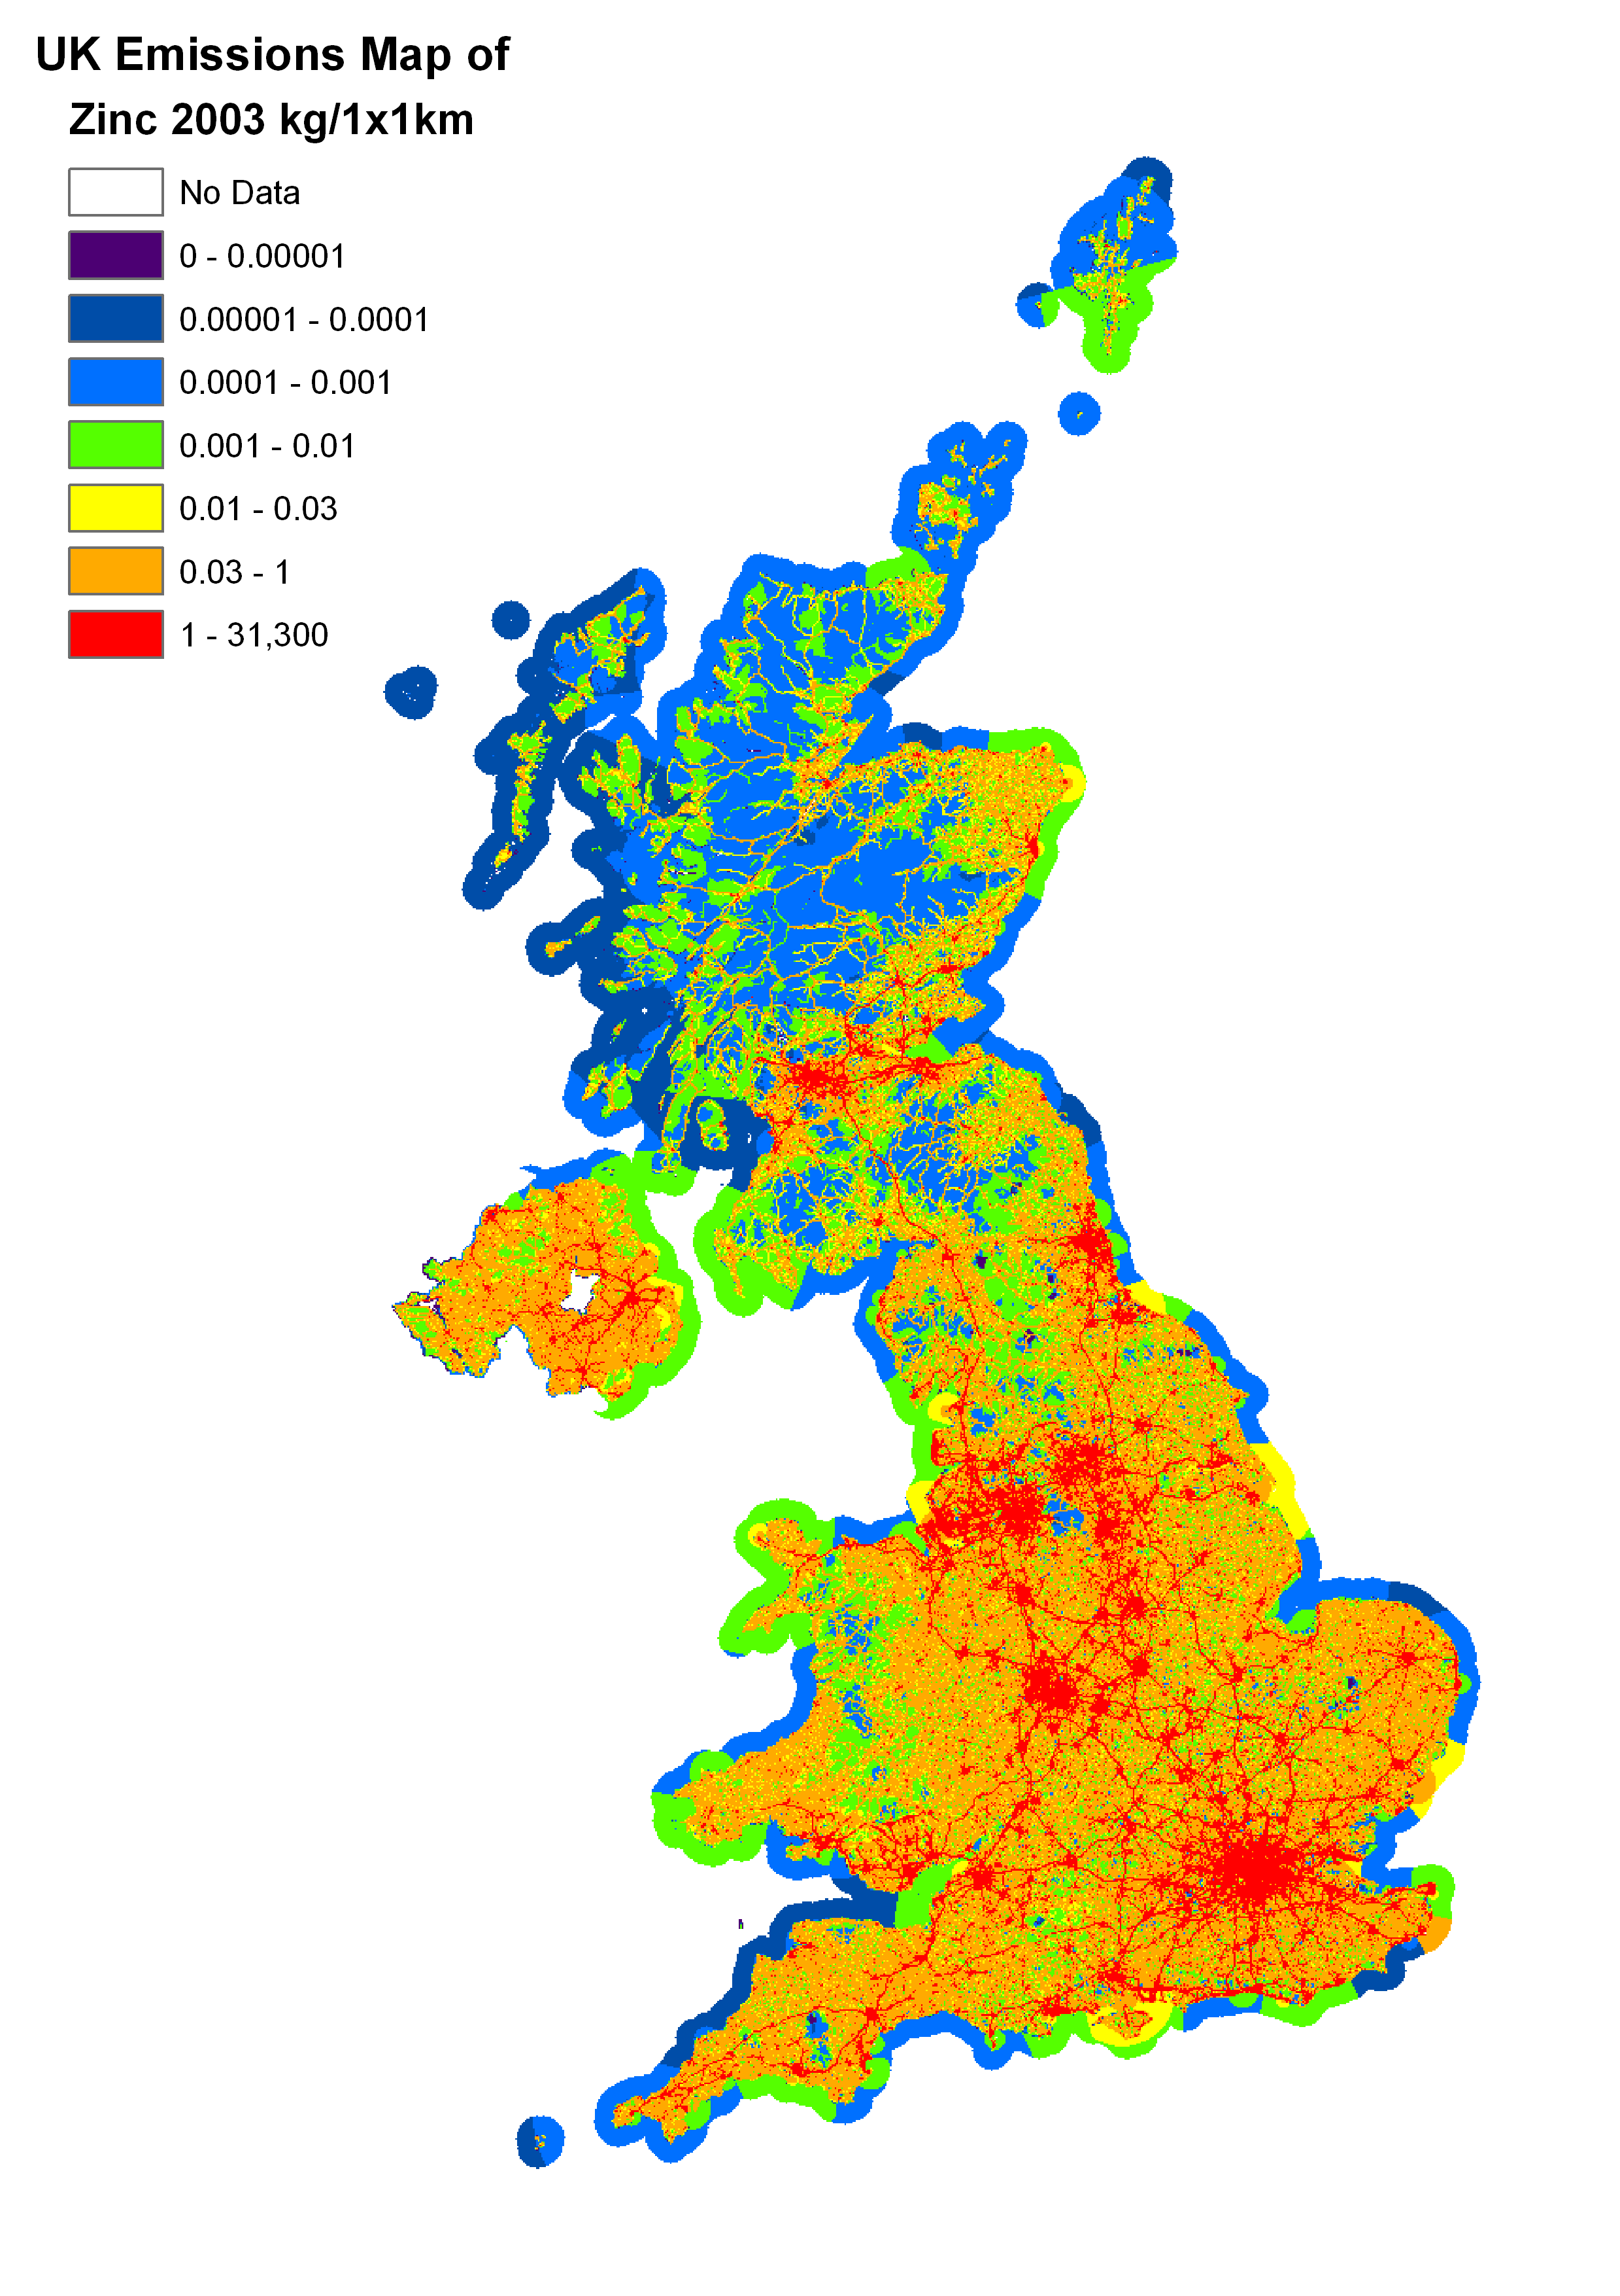

Accuracy of Emission Estimates of Heavy Metals
Quantitative estimates of the uncertainties in emission inventories have been based on calculations made using a direct simulation technique, which corresponds to the IPCC Tier 2 approach recommended for greenhouse gases and also the methodology proposed in draft guidance produced by the UN/ECE Taskforce on Emission Inventories and Projections. This work is described in detail by Passant (2002b). The uncertainty estimates are shown below in Table 6.26.

Table 6.26 Uncertainty of the Emission Inventories for metals
Pollutant | Estimated Uncertainty %
Arsenic | -50 to +100
Cadmium | -20 to +30
Chromium | -30 to +60
Copper | -30 to +50
Lead | -20 to +30
Mercury | -30 to +40
Nickel | -40 to +80
Selenium | -20 to +30
Vanadium | -60 to +100
Zinc | -30 to +50
Beryllium | -70 to +200
Manganese | -80 to +300
Tin | -80 to +300

The inventories for beryllium, manganese and tin are still being developed and are currently much more uncertain than those for other metals.

Among the remaining metal inventories, those for lead and chromium are least uncertain, while those for arsenic, selenium, and vanadium are most uncertain. In the case of lead and chromium, these inventories are less uncertain because of the reliability of estimates for major sources such as road transport in the case of lead, and chromium chemicals in the case of chromium. The inventories for arsenic, selenium and vanadium seem to be most uncertain because of the high uncertainty in estimates of emissions for major sources including burning of impregnated wood (arsenic), flat glass production (selenium), and combustion of fuel oil (vanadium).

